UNITED STATES
SECURITIES AND EXCHANGE COMMISSION
WASHINGTON, D.C. 20549
__________
FORM 8-K
__________
CURRENT REPORT
Pursuant to Section 13 or 15(d) of the Securities Exchange Act of 1934
Date of Report (Date of earliest event reported): August 5, 2026
__________
ROOT, INC.
(Exact name of Registrant as Specified in Its Charter)
__________
Delaware |  |  | 001-39658 |  |  | 84-2717903
(State or Other Jurisdiction  of Incorporation) |  |  | (Commission File Number) |  |  | (IRS Employer  Identification No.)
80 E. Rich Street, Suite 500  Columbus, Ohio |  |  |  |  |  | 43215
(Address of Principal Executive Offices) |  |  |  |  |  | (Zip Code)
(866) 980-9431
(Registrant’s Telephone Number, Including Area Code)
Not Applicable
(Former Name or Former Address, if Changed Since Last Report)
__________
Check the appropriate box below if the Form 8-K filing is intended to simultaneously satisfy the filing obligation of the registrant under any of the following provisions (see General Instructions A.2. below):
☐ Written communications pursuant to Rule 425 under the Securities Act (17 CFR 230.425)
☐ Soliciting material pursuant to Rule 14a-12 under the Exchange Act (17 CFR 240.14a-12)
☐ Pre-commencement communications pursuant to Rule 14d-2(b) under the Exchange Act (17 CFR 240.14d-2(b))
☐ Pre-commencement communications pursuant to Rule 13e-4(c) under the Exchange Act (17 CFR 240.13e-4(c))
Securities registered pursuant to Section 12(b) of the Act:
Title of each class |  |  |  |  |  | Trading Symbol(s) |  |  |  |  |  | Name of each exchange on  which registered
Class A Common Stock, $0.0001 par value |  |  |  |  |  | ROOT |  |  |  |  |  | Nasdaq Stock Market LLC
Indicate by check mark whether the registrant is an emerging growth company as defined in Rule 405 of the Securities Act of 1933 (§230.405 of this chapter) or Rule 12b-2 of the Securities Exchange Act of 1934 (§240.12b-2 of this chapter).
Emerging growth company ☐
If an emerging growth company, indicate by check mark if the registrant has elected not to use the extended transition period for complying with any new or revised financial accounting standards provided pursuant to Section 13(a) of the Exchange Act. ☐

Item 2.02 Results of Operations and Financial Condition.
On August 5, 2026, Root, Inc. (the "Company") announced its financial results for the quarter ended June 30, 2026 by issuing a letter to Shareholders (the "Letter"). A copy of the Letter is furnished as Exhibit 99.1 to this Current Report and incorporated by reference herein.
The information contained in Item 2.02 of this Form 8-K (including Exhibit 99.1 attached hereto) shall not be deemed "filed" for purposes of Section 18 of the Securities Exchange Act of 1934, as amended (the "Exchange Act"), or otherwise subject to the liabilities of that section, nor shall it be deemed incorporated by reference in any filing under the Securities Act of 1933, as amended, or the Exchange Act, except as expressly provided by specific reference in such a filing.
Item 7.01 Regulation FD Disclosure.
The Company prepared an updated investor presentation containing certain information and financial highlights about the Company and its industry, a copy of which will be available on the Company's website at ir.joinroot.com.
No information contained on or accessible through such website shall be deemed to be part of or incorporated by reference into this report. The Company undertakes no duty or obligation to publicly update or revise the information contained in this presentation, although it may do so from time to time.
The information contained in Item 7.01 of this Form 8-K shall not be deemed "filed" for purposes of the Exchange Act, or otherwise subject to the liabilities of that section, nor shall it be deemed incorporated by reference in any filing under the Securities Act of 1933, as amended, or the Exchange Act, except as expressly provided by specific reference in such a filing.
Item 9.01 Financial Statements and Exhibits.
(d) Exhibits
The following exhibit relating to Item 2.02 shall be deemed to be furnished:
Exhibit No. |  |  |  |  |  | Description
99.1 |  |  |  |  |  | Letter to Shareholders, dated August 5, 2026
104 |  |  |  |  |  | The cover page from this Current Report on Form 8-K, formatted in Inline XBRL.

SIGNATURES
Pursuant to the requirements of the Securities Exchange Act of 1934, the registrant has duly caused this report to be signed on its behalf by the undersigned hereunto duly authorized.
 |  |  | ROOT, INC.
Dated: August 5, 2026
 |  |  | By: |  |  | /s/ Alexander Timm
 |  |  |  |  |  | Alexander Timm
 |  |  |  |  |  | Chief Executive Officer and Director



Letter to Shareholders: Q2 2026
____________________________________________________________________________________________________________
Key quarterly metrics
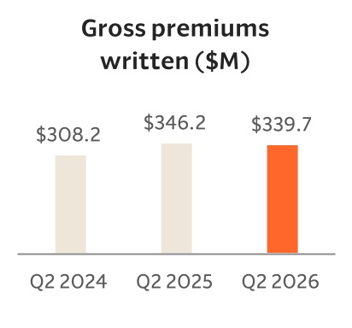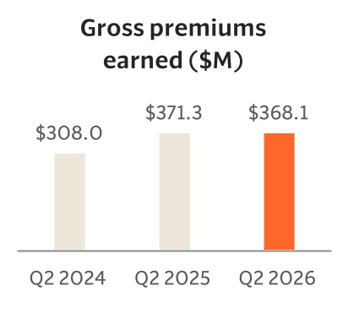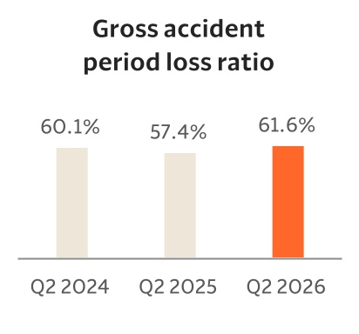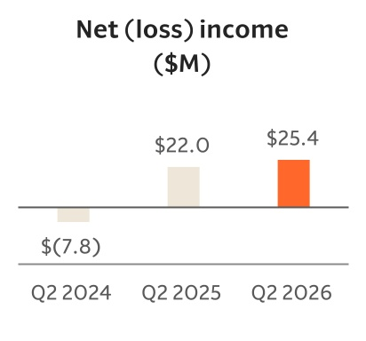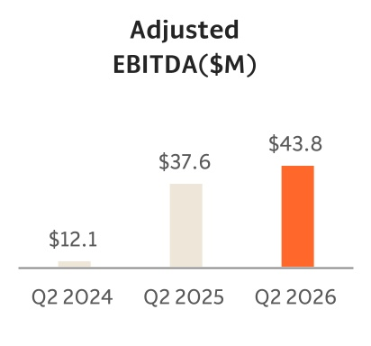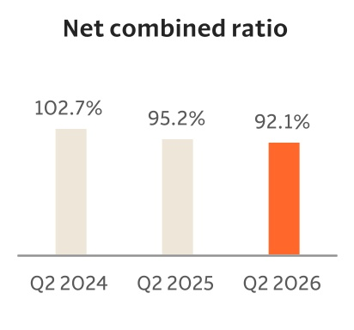

Dear Root Shareholders
We’re happy to report that in the second quarter we continued to generate impressive performance, delivering another strong quarter of profitability while continuing to invest in long-term growth.
During the quarter, we:

1.Delivered strong profitability, with net income increasing 15% year-over-year to $25 million generating approximately 31% annualized return on equity
2.Generated $389 million of revenue, up 2% year-over-year and $44 million of adjusted EBITDA, up 16% year-over-year
3.Ended the quarter with 484 thousand policies in force, up 6% year-over-year while gross written premium of $340 million and gross earned premium of $368 million were down 2% and 1% year-over-year, respectively, as we managed growth with discipline in a competitive Direct market
4.Launched in New Jersey, bringing Root to 37 states and more than 80% of the U.S. population
5.Announced our partnership with Jerry, an insurance shopping platform, further expanding Root’s presence across high-intent digital marketplaces and demonstrating our ability to embed Root’s technology and insurance experience inside partner ecosystems
2
Letter to Shareholders: Q2 2026
____________________________________________________________________________________________________________
6.Continued advancing our next-generation pricing model, expected to launch in the fourth quarter, which we believe will further improve segmentation, customer lifetime value, rate competitiveness, and long-term growth
7.Repurchased more than $20 million of shares under our $75 million share repurchase authorization
These results demonstrate the strength of the technology and data science capabilities we have built over the past decade. When we founded Root, our core belief was simple: insurance would ultimately be won through superior pricing and automation. Long before AI became a mainstream conversation, we built our company around machine learning, quantitative science, and a modern technology platform designed to automate insurance from end to end.
What’s changing is the pace at which AI is expanding what’s possible. The earliest generations of Root’s models relied on structured data and machine learning to improve pricing accuracy beyond traditional actuarial methods. Today, advances in AI and foundation models allow us to extract predictive insights directly from complex, unstructured information while meaningfully accelerating feature generation and model development. Work that once required significant manual effort from data scientists can increasingly be automated, allowing our teams to spend more time making the system itself smarter. At the same time, AI-assisted software development is enabling our engineering teams to build, test, and deploy new capabilities faster than ever. AI has the potential to reshape nearly every part of the insurance lifecycle, from customer acquisition and underwriting to regulatory filings, claims handling, and customer service.
The rapid advancement of AI has reinforced our conviction in technology and automation. Moreover, we believe it strengthens Root’s competitive position when paired with our proprietary data, modern infrastructure, and real operating experience as a regulated insurance carrier. Root’s data assets, including 37 billion miles of driving data and more than 900,000 claims filed, are not generic data sets. They are generated from real customer behavior, real underwriting decisions, and real claims outcomes across our insurance platform. We believe that combination becomes increasingly valuable as AI makes it possible to learn faster, automate more processes, and improve decision-making across the business.
Root has spent the last decade building proprietary data sets on a modern technology platform and developing the operating experience of a regulated insurance carrier. That combination is difficult to replicate. Many large incumbents have scale and data, but continue to modernize decades-old technology stacks. Many newer technology companies have modern software capabilities, but lack the regulatory infrastructure, claims experience, underwriting history, and capital foundation required to operate as an insurance carrier at scale. Massive amounts of data are a prerequisite to training insurance AI models.

3
Letter to Shareholders: Q2 2026
____________________________________________________________________________________________________________
We are building an insurance company for the AI era, one where pricing, underwriting, claims, customer interactions, software development, and capital allocation become increasingly intelligent and automated. We believe the insurance industry is entering a generational technology paradigm shift, and we are uniquely positioned to lead.
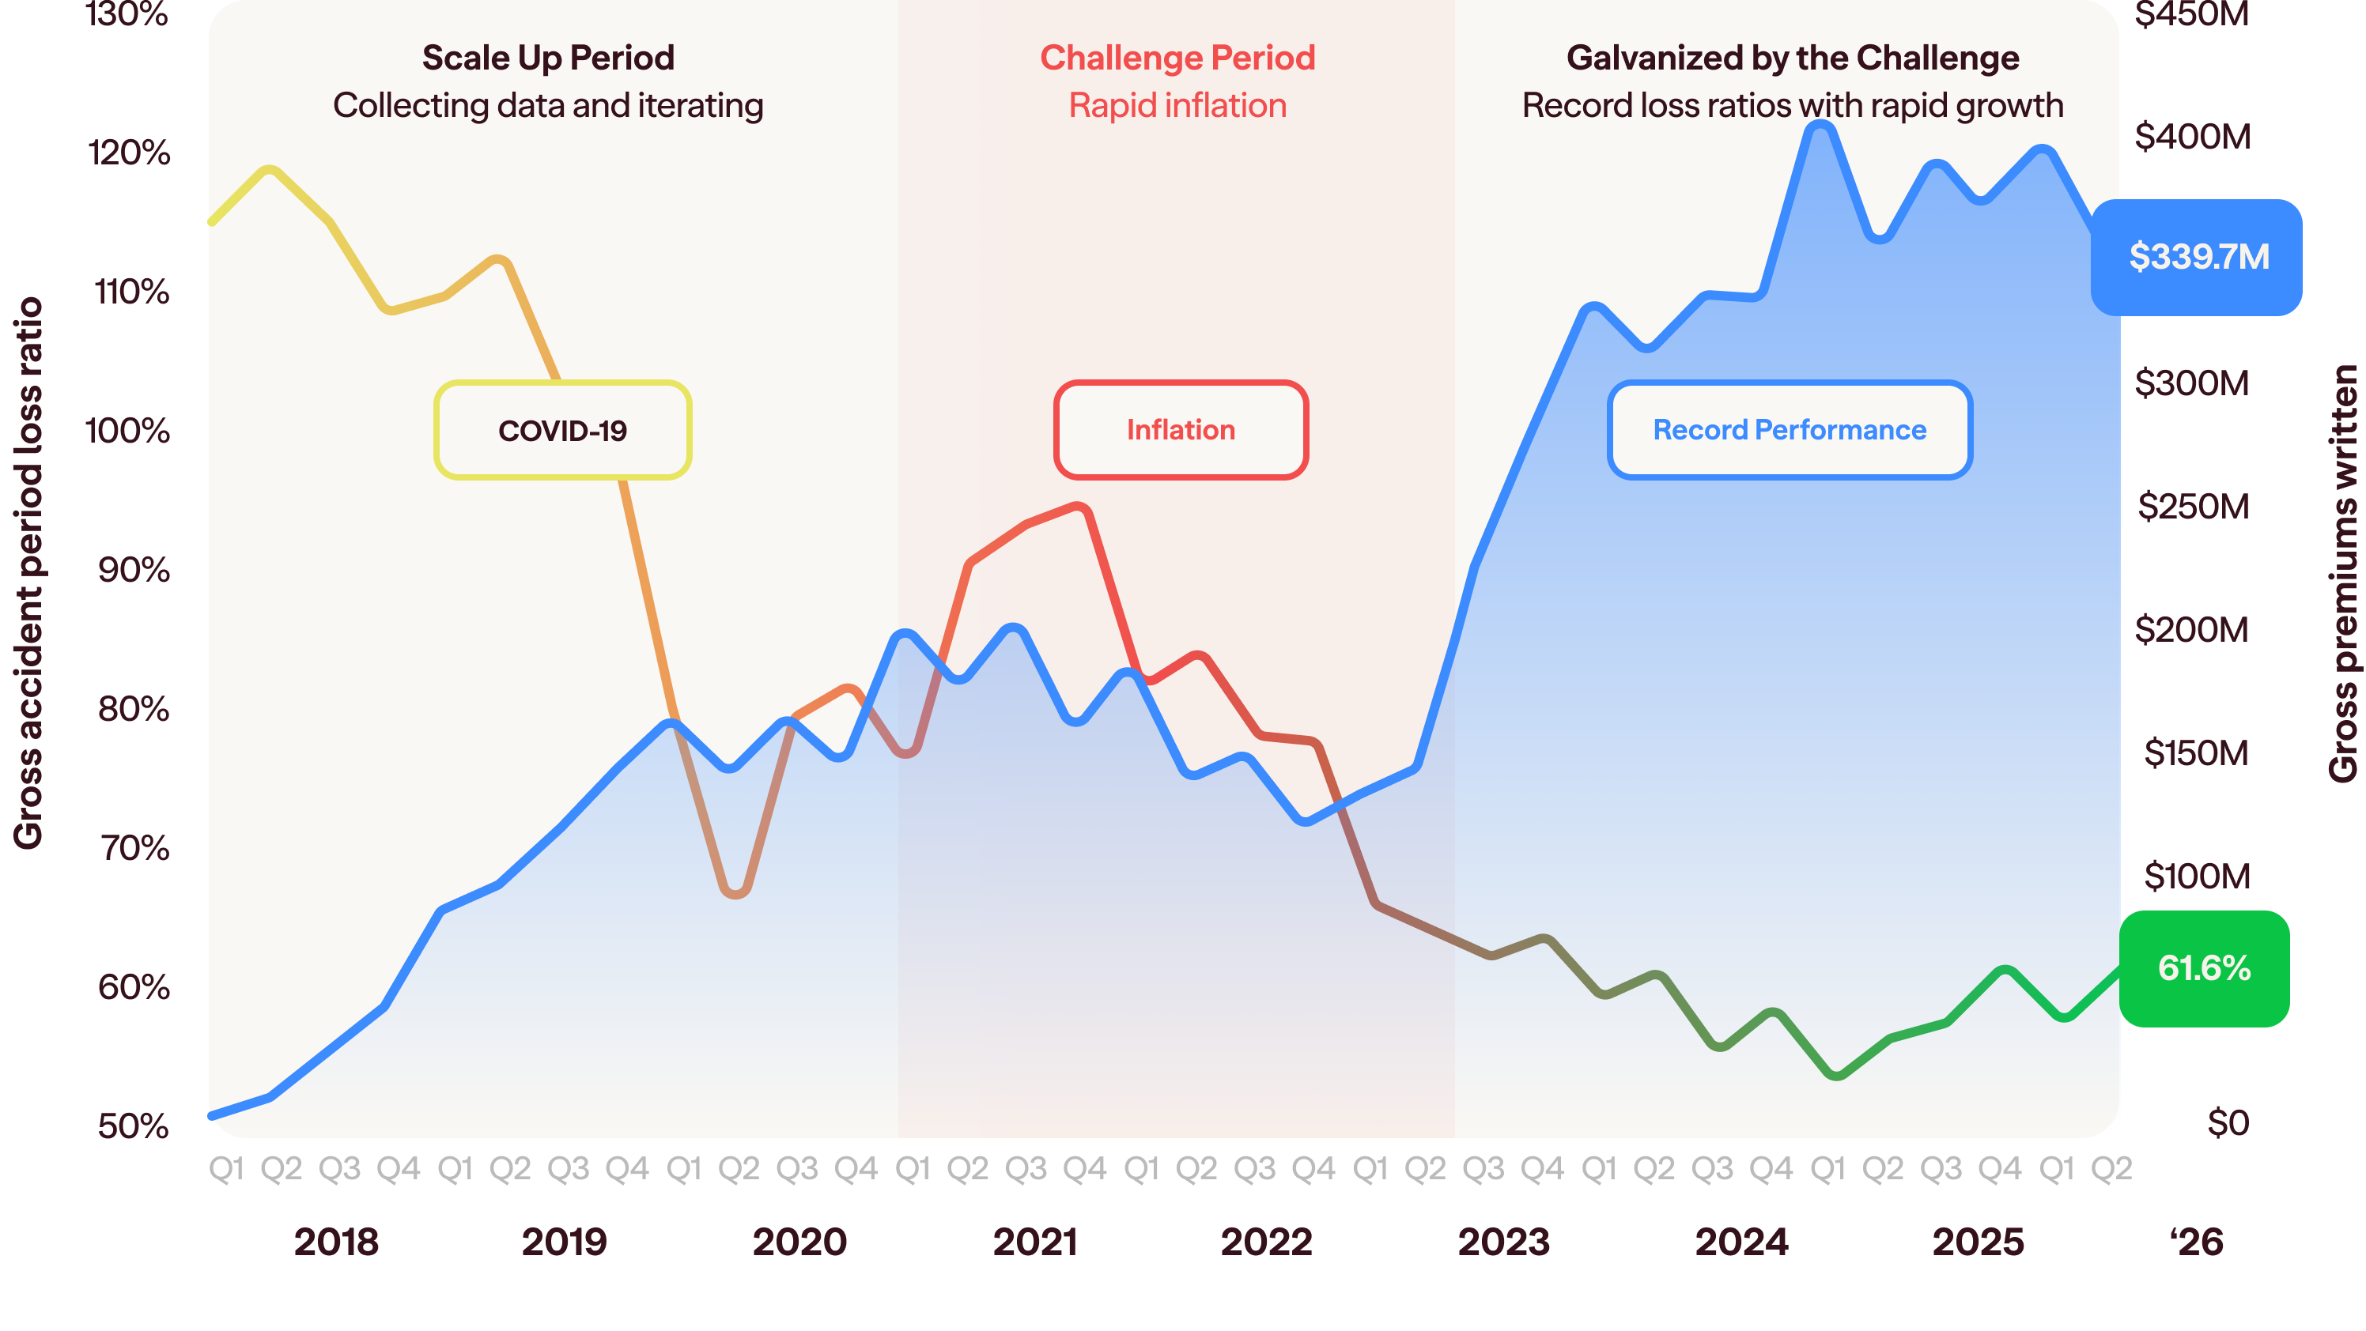

Growth
The competitive environment in Direct remained challenging in the second quarter, as carriers increased marketing spend while lowering prices. When these cycles occur, we remain disciplined: we plan to pursue growth only when it meets our target returns. While that decision can constrain near-term growth, we believe it is the right one for building long-term shareholder value.
Over the medium term, we expect geographic expansion, including our launch in New Jersey, continued growth through independent agents, and expanding partnerships to provide durable growth drivers. Customers are buying insurance in more ways than ever before, and Root has positioned itself across virtually all of these channels—direct, comparison marketplaces, embedded partnerships at the point of vehicle purchase, independent agents, and increasingly AI-enabled customer experiences.
4
Letter to Shareholders: Q2 2026
____________________________________________________________________________________________________________
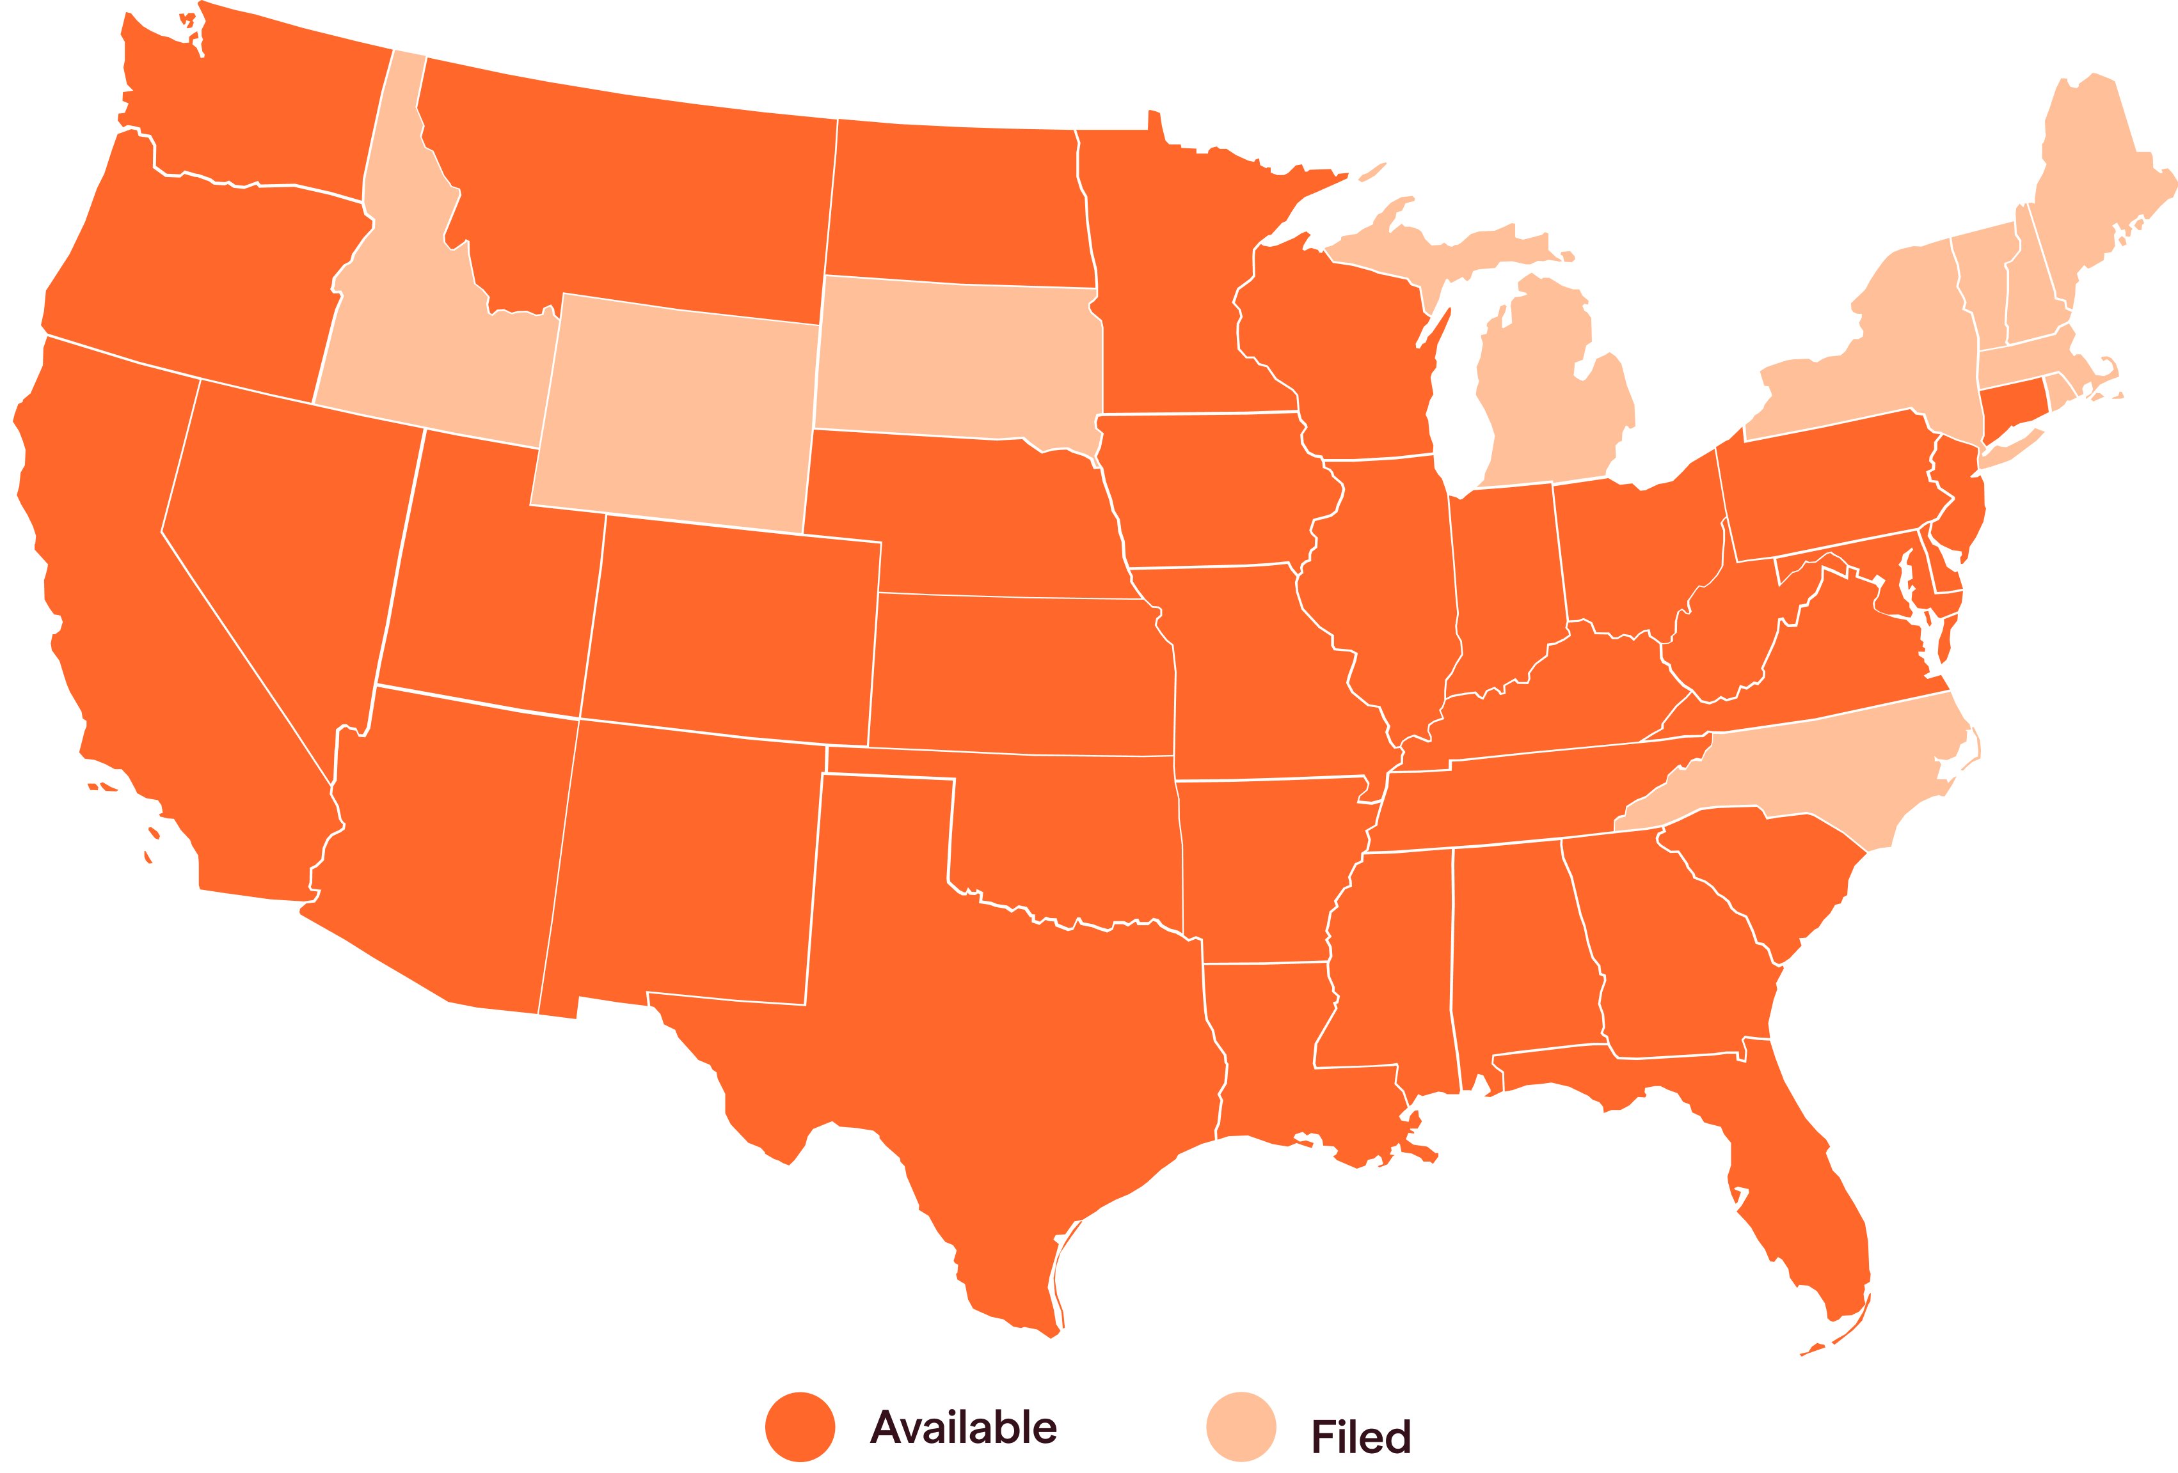

Over the long term, we believe the best growth strategy is to build the best insurance product in the world, and that begins with pricing. Better risk selection enables better prices, stronger unit economics, and a product more customers choose and love.

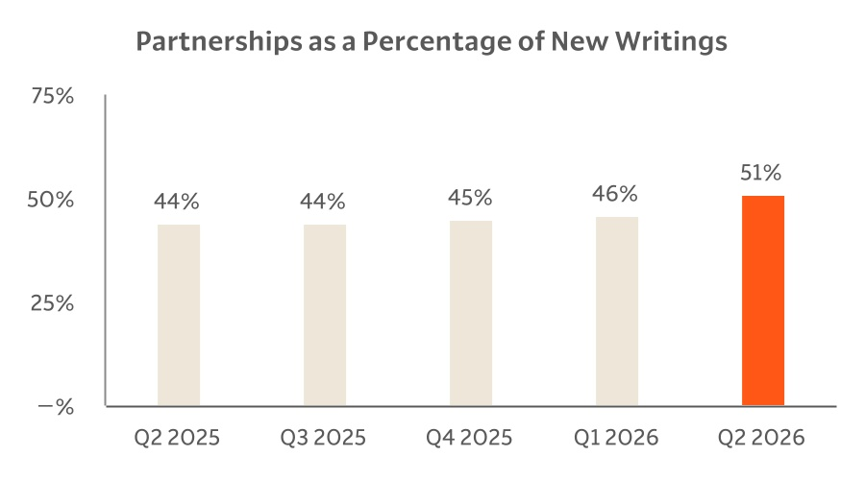

Pricing and Underwriting
Technology is at the heart of who we are and has always been fundamental to how we create value. We built the company on the belief that a modern, fully integrated technology stack—combined with proprietary data and continuously improving predictive models—would allow us to price risk more accurately and operate more efficiently than traditional carriers.
Our second-quarter results demonstrate the strength of that foundation. We delivered a 92.1% net combined ratio reflecting the continued profitability and underwriting discipline of the business. These results provide tangible
5
Letter to Shareholders: Q2 2026
____________________________________________________________________________________________________________
evidence that our investments in technology, enhanced by AI, and pricing are producing meaningful outcomes today.
At the same time, we continue to invest in what comes next. We expect to launch our newest predictive pricing model in the fourth quarter, and early results from research and development are highly encouraging. We continue to see meaningful gains as more underwriting, pricing, and behavioral data enter our system and strengthen our models.
The opportunity ahead is not simply to develop a better model. It is to create an increasingly intelligent, automated insurance company—one that learns faster, prices more precisely, and delivers a better customer experience at a lower cost. That is the company we have always been building, and we believe AI compounds the potential of this foundation.

Gross accident period loss ratio
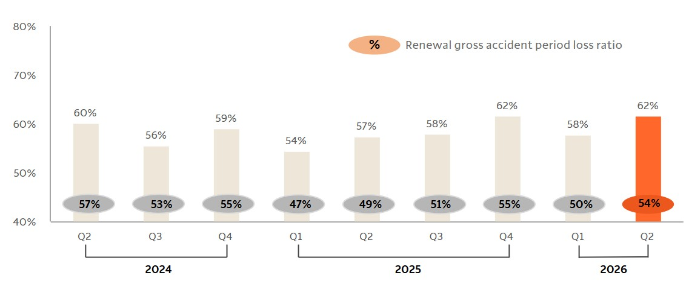

Financials
In the second quarter, we generated $389 million of revenue, a 2% increase year-over-year. Net income was $25 million, an increase of $3 million or 15% year-over-year, and adjusted EBITDA was $44 million, an increase of $6 million or 16% year-over-year.
Gross written premium was $340 million and gross earned premium was $368 million, down 2% and 1% year-over-year, respectively. Policies in force ended the quarter at 484 thousand, up 6% year-over-year. The quarter reflected more selective growth in a competitive Direct market, while our profitability remained strong.
6
Letter to Shareholders: Q2 2026
____________________________________________________________________________________________________________
Partnership and independent agent channels represented approximately 51% of new writings in the quarter, up from approximately 44% in the prior-year period, reflecting continued progress diversifying growth beyond Direct.
Net underwriting margin improved 3.1 points year-over-year to 7.9%, equivalent to a 92.1% net combined ratio, driven primarily by continued expense discipline. Net expense ratio improved 3.0 points year-over-year to 26.1%, while net loss and LAE ratio was 66.0%, broadly in line with the prior-year period.
Our results reflect a business that can generate meaningful earnings while continuing to invest behind growth, technology, pricing, and distribution.
During the quarter, we successfully refinanced our existing $200 million debt into a new term loan facility led by The Huntington National Bank, reducing our cost of debt and increasing financial flexibility. We also repurchased more than $20 million of our shares under our $75 million share repurchase authorization during the second quarter.
We view share repurchases as one of several capital allocation tools available to us. They are part of the same framework we use to evaluate all uses of capital: organic growth, technology investment, partnerships, strategic opportunities, and returning capital to shareholders. We continue to maintain meaningful financial flexibility and remain disciplined in how we allocate capital.

Looking Forward
We are expanding our national footprint, deepening our distribution capabilities, advancing our pricing models, and building the technology platform we believe will define the next decade of insurance.
Thank you to our team members for their hard work, to our customers for their trust, and to our shareholders for their support.


Alex Timm
Co-Founder & CEO

7
Letter to Shareholders: Q2 2026
____________________________________________________________________________________________________________
Non-GAAP financial measures
This letter and statements made during our earnings webcast may include information relating to Direct Contribution and Adjusted EBITDA, which are "non-GAAP financial measures" and are defined below. These non-GAAP financial measures have not been calculated in accordance with generally accepted accounting principles in the United States, or GAAP, and should be considered in addition to results prepared in accordance with GAAP and should not be considered as a substitute for, or superior to, GAAP results.
In addition, Direct Contribution and Adjusted EBITDA should not be construed as indicators of our operating performance, liquidity, or cash flows generated by operating, investing and financing activities, as there may be significant factors or trends that they fail to address. We caution investors that non-GAAP financial information, by its nature, departs from traditional accounting conventions. Therefore, its use can make it difficult to compare our current results with our results from other reporting periods and with the results of other companies.
Our management uses these non-GAAP financial measures, in conjunction with GAAP financial measures, as an integral part of managing our business and to, among other things: (1) monitor and evaluate the performance of our business operations and financial performance, (2) facilitate internal comparisons of the historical operating performance of our business operations, (3) facilitate external comparisons of the results of our overall business to the historical operating performance of other companies that may have different capital structures and debt levels, (4) review and assess the performance of our management team, including when determining incentive compensation, (5) analyze and evaluate financial and strategic planning decisions regarding future operating investments, and (6) plan for and prepare future annual operating budgets and determine appropriate levels of operating investments.
For more information regarding the non-GAAP financial measures discussed in this release, please see “Non-GAAP financial measures,” Reconciliation of Total Revenue to Direct Contribution” and “Reconciliation of Net Income (Loss) to Adjusted EBITDA” below and in Root’s Quarterly Report on Form 10-Q at http://ir.joinroot.com or the SEC’s website at www.sec.gov.

8
Letter to Shareholders: Q2 2026
____________________________________________________________________________________________________________
Defined Terms & Glossary
We utilize the following definitions for terms used in this letter.
AI: Artificial intelligence
Direct Contribution
We define direct contribution, a non-GAAP financial measure, as gross profit excluding net investment income, net realized gains on investments, acquisition expenses, which include report costs and commission expenses related to our partnership channel, and fixed expenses, which include certain warrant compensation expense related to policies originating through the integrated automobile insurance solution for Carvana’s online buying platform, overhead allocated based on headcount, or Overhead, and salaries, health benefits, bonuses, employee retirement plan-related expenses and employee share-based compensation expense, or Personnel Costs, licenses, professional fees and other expenses. Further impacts related to reinsurance are excluded, these consist of ceded premiums earned, ceded loss and LAE, and net ceding commission and other. Net ceding commission and other is comprised of ceding commission received in connection with reinsurance ceded, partially offset by amortization of excess ceding commission, and other impacts of reinsurance ceded which are included in other insurance expense. After these adjustments, the resulting calculation is inclusive of only those gross variable costs of revenue incurred on the successful acquisition of business. We view direct contribution as an important metric because we believe it measures profitability of our total policy portfolio prior to the impact of reinsurance.
Adjusted EBITDA
We define adjusted EBITDA, a non-GAAP financial measure, as net income excluding interest expense, income tax expense, depreciation and amortization, share-based compensation, loss on extinguishment of debt, warrant compensation expense, restructuring charges, certain legal fees and other items that do not reflect our ongoing operating performance. After these adjustments, the resulting calculation represents expenses directly attributable to our operating performance. We use adjusted EBITDA as an internal performance measure in the management of our operations because we believe it provides management and other users of our financial information useful insight into our results of operations and underlying business performance. Adjusted EBITDA should not be viewed as a substitute for net income calculated in accordance with GAAP, and other companies may define adjusted EBITDA differently.

Encumbered Capital
We define encumbered capital as cash and cash equivalents held within our regulated insurance entities.
Unencumbered Capital
We define unencumbered capital as unrestricted cash and cash equivalents held outside of our regulated insurance entities. This amount includes borrowed funds that are subject to certain minimum liquidity covenants.
9
Letter to Shareholders: Q2 2026
____________________________________________________________________________________________________________
Gross Accident Period Loss Ratio
Gross accident period loss ratio, expressed as a percentage, represents all losses and claims expected to arise from insured events that occurred during the applicable period regardless of when they are reported and finally settled divided by gross premiums earned for the same period. The gross accident period loss ratio is remeasured each reporting period to reflect updated estimates of ultimate losses as they develop.
Distribution Channels
•Direct: seamless experiences driven by performance marketing and organic traffic connecting consumers directly to the product.
◦Digital. Our direct digital channel is designed to drive volume by efficiently capturing high-intent customers. We accomplish this by meeting our customers within platforms they use extensively such as search engines or select marketplace platforms where consumers are actively shopping for insurance. We deploy dynamic data science models to optimize advertising, targeting, and bidding strategies across our digital platforms, aligning customer acquisition cost to expected lifetime value of the potential customer.
◦Referral. We encourage our existing customers to spread our value proposition. Our referral channel compensates existing customers who refer new customers who subsequently complete a test drive. This channel facilitates community-based growth to those who value our fair and transparent approach to insurance. This is our lowest cost acquisition channel and an important aspect of our ongoing distribution and brand strategy.
◦Channel Media. We build consideration and drive intent through household-level targeted media channels including direct mail, social media, and digital media. We conduct experimental structured tests across media channels and geographies through a disciplined test-and-learn approach to evaluate new tactics. These efforts are intended to support expansion beyond high-intent acquisition channels while maintaining focus on efficiency and long-term value creation. We utilize these media channels to drive awareness when launching in new markets and to target prospective customers in active states.
10
Letter to Shareholders: Q2 2026
____________________________________________________________________________________________________________
•Partnership: a wide array of integrations, spanning early-stage marketing partnerships through fully embedded user experiences.
◦Automotive & Financial Services. We build upon or within the mobile and web customer experiences of our automotive and financial services distribution partners to reach a captive customer base with an integrated solution. Our flexible technology stack allows us to meet our partners where they are with the best solution for them with varying levels of connectivity, including our proprietary and fully integrated application which removes the need for the customer to ever visit a Root website to purchase and bind a policy. While these partnerships take time to onboard and launch, over the long term, we believe our platform will deliver a seamless bind experience, creating a differentiated customer experience in this channel. We expect increased penetration of this channel over time as we seek to grow relationships with other automotive and financial service companies with relevant customer bases.
◦Independent Agent. We continue to invest in a product to bring the speed and ease of our technology to the independent agent channel. This channel provides access to a larger demographic of customers and we believe it has staying power. We developed an efficient quote and bind process through our independent agent platform that enables simplified distribution from independent agents to their customers. Technology is at the core of the experience, enabling licensed independent agents to onboard quickly and seamlessly integrate with the comparative raters that many are already using. This allows us to offer our insurance products to customers alongside other established insurance carriers. The technology driven approach makes this an appealing platform for independent agents and an efficient acquisition channel for us.

About Root, Inc.
Founded in 2015 and based in Columbus, Ohio, Root, Inc. (NASDAQ: ROOT) is the parent company of Root Insurance Company. Root is revolutionizing insurance through data science and technology to provide consumers a personalized, easy, and fair experience. The Root app has roughly 18 million app downloads and has collected 37 billion miles of driving data to inform their insurance offerings.
For further information on Root, please visit root.com.
11
Letter to Shareholders: Q2 2026
____________________________________________________________________________________________________________
Root Insurance Company and Root Property & Casualty Insurance Company are headquartered in Columbus, Ohio, with renters insurance available through Root Insurance Company in Arkansas, Georgia, Kentucky, Missouri, Nevada, New Mexico, Ohio, Tennessee, and Utah. Root, Inc. is active in 37 markets for auto insurance: Alabama, Arizona, Arkansas, California, Colorado, Connecticut, Delaware, Florida, Georgia, Illinois, Indiana, Iowa, Kansas, Kentucky, Louisiana, Maryland, Minnesota, Mississippi, Missouri, Montana, Nebraska, Nevada, New Jersey, New Mexico, North Dakota, Ohio, Oklahoma, Oregon, Pennsylvania, South Carolina, Tennessee, Texas, Utah, Virginia, Washington, West Virginia, and Wisconsin. Business is underwritten by Root Insurance Company and/or Root Property & Casualty Insurance Company depending on the market. In Texas, we also write business as a Managing General Agent, underwritten by Redpoint County Mutual Insurance Company. Carvana Insurance built with Root is exclusively offered, subject to limited exceptions, in the states where Root writes insurance.
12
Letter to Shareholders: Q2 2026
____________________________________________________________________________________________________________

Forward-looking statements
This letter contains—and statements made during the above-referenced webcast will contain— forward-looking statements relating to, among other things, the future performance of Root and its consolidated subsidiaries that are based on Root’s current expectations, forecasts, and assumptions, and involve substantial risks and uncertainties. In some cases, you can identify forward-looking statements because they contain words such as “anticipate,” “believe,” “contemplate,” “continue,” “could,” “estimate,” “expect,” “intend,” “may,” “path,” “plan,” “potential,” “predict,” “project,” “should,” “target,” “will” or “would” or the negative of these words or other similar terms or expressions. These include, but are not limited to, statements concerning the following:
•our share repurchase expectations;
•the anticipated benefits of our new senior secured term loan;
•our expected financial results for 2026;
•our ability to retain existing customers, acquire new customers and expand our customer reach;
•our expectations regarding our future financial performance, including total revenue, gross profit, net income, direct contribution, adjusted EBITDA, net loss and loss adjustment expense, or LAE, ratio, net expense ratio, net combined ratio, gross loss ratio, marketing costs and costs of customer acquisition, gross LAE ratio, gross expense ratio, gross combined ratio, operating expenses, quota share levels, changes in unencumbered cash balances and expansion of our new and renewal premium base;
•our ability to realize profits, acquire customers, retain customers, contract with additional partners to utilize the products, or achieve other benefits from our embedded insurance offering;
•our ability to expand our distribution channels through additional partnership relationships, digital media, independent agents and referrals;
•our ability to maintain, and drive a significant long-term competitive advantage through, our partnership with Carvana Group, LLC, or Carvana, and other partnerships, such as our partnerships with Hyundai Capital America, Toyota, Experian and Jerry;
•our ability to develop products for embedded insurance and other partners;
•the impact of geopolitical instability, supply chain disruptions, increasing inflation, a potential increase in tariffs or the implementation of new tariffs, a recession and/or disruptions to properly functioning financial and capital markets and interest rates on our business and financial condition;
•our ability to remain profitable and extend our capital runway;
•our goal to be licensed in all states in the United States and the timing of obtaining additional licenses and launching in new states;
13
Letter to Shareholders: Q2 2026
____________________________________________________________________________________________________________
•the accuracy and efficiency of our telematics and behavioral data, and our ability to gather and leverage existing and additional data;
•our ability to materially improve retention rates and our ability to realize benefits from retaining customers;
•our ability to underwrite risks accurately and charge profitable rates;
•our ability to maintain our business model and improve our capital and marketing efficiency;
•our ability to drive improved conversion and decrease the cost of customer acquisition;
•our ability to maintain and enhance our brand and reputation;
•our ability to effectively manage the growth of our business;
•our ability to raise additional capital efficiently or at all;
•our ability to improve our product offerings, introduce new products and expand into additional insurance lines;
•our ability to cross sell our products and attain greater value from each customer;
•our ability to compete effectively with existing competitors and new market entrants in our industry;
•future performance of the markets in which we operate;
•our ability to operate a “capital-efficient” business and obtain and maintain desirable levels of reinsurance;
•the effect of further reductions in the utilization of reinsurance, which would result in retention of more premium and losses and could cause our capital requirements to increase;
•our ability to realize economies of scale;
•our ability to attract, motivate and retain key personnel, or hire personnel, and to offer competitive compensation and benefits;
•our ability to deliver a vertically integrated customer experience;
•our ability to develop products that utilize telematics to drive better customer satisfaction and retention;
•our ability to protect our intellectual property and any costs associated therewith;
•our ability to develop an autonomous claims experience;
•our ability to take rate action early and react to changing environments;
•our ability to meet risk-based capital requirements;
•our ability to realize benefits from our Texas county mutual fronting arrangement;
14
Letter to Shareholders: Q2 2026
____________________________________________________________________________________________________________
•our ability to expand domestically;
•our ability to comply with laws and regulations that currently apply or become applicable to our business;
•the impact of litigation or other losses;
•changes in laws or regulations, or changes in the interpretation of laws or regulations by a regulatory authority, specific to the use of artificial intelligence, telematics data and the consent to use telematics data, connected-car data, and other sources of data, or relating to taxation, including changes in tax regulations, or guidance promulgated pursuant to the new legislation implemented in the One Big Beautiful Bill Act;
•the impact of moratoriums, mandates and similar regulations or requests related to federal government shutdowns or other economic disruptions that negatively impact our ability to charge or increase premiums or result in increased premium write-offs;
•our ability to defend against cybersecurity threats and prevent, or recover from, a security incident or other significant disruption of our technology systems or those of our partners and third-party service providers;
•the effect of interest rates on our available cash and our ability to maintain compliance with our new term loan;
•our ability to maintain proper and effective internal control over financial reporting; and
•the growth rates of the markets in which we compete.
Root’s actual results could differ materially from those predicted or implied by such forward-looking statements, and reported results should not be considered as an indication of future performance.
Factors that could cause or contribute to such differences also include, but are not limited to, those factors that could affect Root’s business, operating results, and stock price included under the captions “Risk Factors” and “Management’s Discussion and Analysis of Financial Condition and Results of Operations” in Root’s 2025 Annual Report on Form 10-K, our Quarterly Reports on Form 10-Q, and other filings with the SEC at http://ir.joinroot.com or the SEC’s website at www.sec.gov.
Undue reliance should not be placed on the forward-looking statements in this letter or the above-referenced webcast, which are based on information available to Root on the date hereof. We assume no obligation to update such statements.

15
Letter to Shareholders: Q2 2026
____________________________________________________________________________________________________________
Financial statements
ROOT, INC. AND SUBSIDIARIES
CONDENSED CONSOLIDATED BALANCE SHEETS - UNAUDITED
 |  |  | As of
 |  |  | June 30, |  |  |  |  |  | December 31,
 |  |  | 2026 |  |  |  |  |  | 2025
 |  |  | (in millions, except par value )
Assets
Investments:
Fixed maturities available-for-sale, at fair value (amortized cost: $508.3 and $383.1 at June 30, 2026 and December 31, 2025, respectively) |  |  | $ | 506.3 |  |  |  |  | $ | 387.0
Short-term investments (amortized cost: $10.8 and zero at June 30, 2026 and December 31, 2025, respectively) |  |  | 10.8 |  |  |  |  |  | —
Other investments |  |  | — |  |  |  |  |  | 4.4
Total investments |  |  | 517.1 |  |  |  |  |  | 391.4
Cash and cash equivalents |  |  | 509.6 |  |  |  |  |  | 669.3
Restricted cash and cash equivalents |  |  | 65.2 |  |  |  |  |  | 20.6
Premiums receivable, net of allowance of $8.5 and $8.9 at June 30, 2026 and December 31, 2025, respectively |  |  | 330.7 |  |  |  |  |  | 332.8
Reinsurance premiums receivable, net of allowance of zero at June 30, 2026 and December 31, 2025 |  |  | 87.0 |  |  |  |  |  | 96.3
Reinsurance recoverable, net of allowance of $0.1 at June 30, 2026 and December 31, 2025 |  |  | 25.2 |  |  |  |  |  | 33.5
Deferred policy acquisition costs |  |  | 47.1 |  |  |  |  |  | 44.4
Other assets |  |  | 86.6 |  |  |  |  |  | 86.2
Total assets |  |  | $ | 1,668.5 |  |  |  |  | $ | 1,674.5
Liabilities, Redeemable Convertible Preferred Stock and Stockholders’ Equity
Liabilities:
Loss and loss adjustment expense reserves |  |  | $ | 489.2 |  |  |  |  | $ | 483.6
Unearned premiums |  |  | 384.0 |  |  |  |  |  | 393.7
Long-term debt |  |  | 197.8 |  |  |  |  |  | 200.3
Premiums payable |  |  | 87.6 |  |  |  |  |  | 96.7
Accounts payable and accrued expenses |  |  | 47.9 |  |  |  |  |  | 74.2
Other liabilities |  |  | 22.1 |  |  |  |  |  | 29.7
Total liabilities |  |  | 1,228.6 |  |  |  |  |  | 1,278.2
Commitments and Contingencies
Redeemable convertible preferred stock, $0.0001 par value, 100.0 shares authorized, 14.1 shares issued and outstanding at June 30, 2026 and December 31, 2025 (redemption value of $126.5) |  |  | 112.0 |  |  |  |  |  | 112.0
Stockholders’ equity:
Class A common stock, $0.0001 par value, 1,000.0 shares authorized, 13.7 shares issued and outstanding at June 30, 2026 and December 31, 2025 |  |  | — |  |  |  |  |  | —
Class B convertible common stock, $0.0001 par value, 269.0 shares authorized, 1.8 shares issued and outstanding at June 30, 2026 and December 31, 2025 |  |  | — |  |  |  |  |  | —
Additional paid-in capital |  |  | 1,910.2 |  |  |  |  |  | 1,922.0
Accumulated other comprehensive (loss) income |  |  | (2.0) |  |  |  |  |  | 3.9
Accumulated loss |  |  | (1,580.3) |  |  |  |  |  | (1,641.6)
Total stockholders’ equity |  |  | 327.9 |  |  |  |  |  | 284.3
Total liabilities, redeemable convertible preferred stock and stockholders’ equity |  |  | $ | 1,668.5 |  |  |  |  | $ | 1,674.5
16
Letter to Shareholders: Q2 2026
____________________________________________________________________________________________________________
ROOT, INC. AND SUBSIDIARIES
CONDENSED CONSOLIDATED STATEMENTS OF OPERATIONS AND COMPREHENSIVE INCOME - UNAUDITED
 |  |  | Three Months Ended June 30, |  |  |  |  |  |  |  |  |  |  |  | Six Months Ended June 30,
 |  |  | 2026 |  |  |  |  |  | 2025 |  |  |  |  |  | 2026 |  |  |  |  |  | 2025
 |  |  | (in millions, except per share data)
Revenues:
Net premiums earned |  |  | $ | 363.5 |  |  |  |  | $ | 353.0 |  |  |  |  | $ | 727.2 |  |  |  |  | $ | 674.3
Net investment income |  |  | 5.0 |  |  |  |  |  | 9.4 |  |  |  |  |  | 13.7 |  |  |  |  |  | 18.1
Net realized gains on investments |  |  | — |  |  |  |  |  | — |  |  |  |  |  | 0.1 |  |  |  |  |  | —
Fee income |  |  | 19.8 |  |  |  |  |  | 19.7 |  |  |  |  |  | 40.1 |  |  |  |  |  | 38.4
Other income |  |  | 0.9 |  |  |  |  |  | 0.8 |  |  |  |  |  | 1.6 |  |  |  |  |  | 1.5
Total revenues |  |  | 389.2 |  |  |  |  |  | 382.9 |  |  |  |  |  | 782.7 |  |  |  |  |  | 732.3
Operating expenses:
Loss and loss adjustment expenses |  |  | 239.9 |  |  |  |  |  | 233.3 |  |  |  |  |  | 466.1 |  |  |  |  |  | 438.9
Sales and marketing |  |  | 25.3 |  |  |  |  |  | 37.1 |  |  |  |  |  | 52.6 |  |  |  |  |  | 88.6
Other insurance expense |  |  | 58.4 |  |  |  |  |  | 47.9 |  |  |  |  |  | 117.8 |  |  |  |  |  | 84.6
Technology and development |  |  | 15.5 |  |  |  |  |  | 13.7 |  |  |  |  |  | 30.7 |  |  |  |  |  | 25.1
General and administrative |  |  | 15.5 |  |  |  |  |  | 23.6 |  |  |  |  |  | 40.0 |  |  |  |  |  | 44.1
Total operating expenses |  |  | 354.6 |  |  |  |  |  | 355.6 |  |  |  |  |  | 707.2 |  |  |  |  |  | 681.3
Operating income |  |  | 34.6 |  |  |  |  |  | 27.3 |  |  |  |  |  | 75.5 |  |  |  |  |  | 51.0
Interest expense |  |  | 4.1 |  |  |  |  |  | 5.3 |  |  |  |  |  | 8.9 |  |  |  |  |  | 10.6
Loss on extinguishment of debt |  |  | 4.9 |  |  |  |  |  | — |  |  |  |  |  | 4.9 |  |  |  |  |  | —
Income before income tax expense |  |  | 25.6 |  |  |  |  |  | 22.0 |  |  |  |  |  | 61.7 |  |  |  |  |  | 40.4
Income tax expense |  |  | 0.2 |  |  |  |  |  | — |  |  |  |  |  | 0.4 |  |  |  |  |  | —
Net income |  |  | 25.4 |  |  |  |  |  | 22.0 |  |  |  |  |  | 61.3 |  |  |  |  |  | 40.4
Net income attributable to participating securities |  |  | 1.3 |  |  |  |  |  | 1.1 |  |  |  |  |  | 3.0 |  |  |  |  |  | 2.0
Net income attributable to common shareholders |  |  | 24.1 |  |  |  |  |  | 20.9 |  |  |  |  |  | 58.3 |  |  |  |  |  | 38.4
Other comprehensive (loss) income:
Net income |  |  | 25.4 |  |  |  |  |  | 22.0 |  |  |  |  |  | 61.3 |  |  |  |  |  | 40.4
Changes in net unrealized (losses) gains on investments |  |  | (2.4) |  |  |  |  |  | 1.6 |  |  |  |  |  | (5.9) |  |  |  |  |  | 4.6
Comprehensive income |  |  | $ | 23.0 |  |  |  |  | $ | 23.6 |  |  |  |  | $ | 55.4 |  |  |  |  | $ | 45.0
Earnings per common share: (both Class A and B)
Basic |  |  | $ | 1.54 |  |  |  |  | $ | 1.36 |  |  |  |  | $ | 3.74 |  |  |  |  | $ | 2.51
Diluted |  |  | $ | 1.49 |  |  |  |  | $ | 1.29 |  |  |  |  | $ | 3.58 |  |  |  |  | $ | 2.36
Weighted-average common shares outstanding: (both Class A and B)
Basic |  |  | 15.7 |  |  |  |  |  | 15.4 |  |  |  |  |  | 15.6 |  |  |  |  |  | 15.3
Diluted |  |  | 17.0 |  |  |  |  |  | 17.1 |  |  |  |  |  | 17.1 |  |  |  |  |  | 17.1
17
Letter to Shareholders: Q2 2026
____________________________________________________________________________________________________________
ROOT, INC. AND SUBSIDIARIES
CONDENSED CONSOLIDATED STATEMENTS OF CASH FLOWS - UNAUDITED
 |  |  | Six Months Ended June 30,
 |  |  | 2026 |  |  |  |  |  | 2025
 |  |  | (in millions)
Cash flows from operating activities:
Net income |  |  | $ | 61.3 |  |  |  |  | $ | 40.4
Adjustments to reconcile net income to net cash provided by operating activities:
Share-based compensation |  |  | 16.0 |  |  |  |  |  | 14.8
Warrant compensation expense |  |  | 3.5 |  |  |  |  |  | —
Depreciation and amortization |  |  | 5.8 |  |  |  |  |  | 4.0
Bad debt expense |  |  | 19.1 |  |  |  |  |  | 17.8
Loss on extinguishment of debt |  |  | 4.9 |  |  |  |  |  | —
Net realized gains on investments |  |  | (0.1) |  |  |  |  |  | —
Change in fair value of equity securities |  |  | 4.4 |  |  |  |  |  | —
Changes in operating assets and liabilities:
Premiums receivable |  |  | (17.0) |  |  |  |  |  | (53.8)
Reinsurance premiums receivable |  |  | 9.3 |  |  |  |  |  | (14.2)
Reinsurance recoverable |  |  | 8.3 |  |  |  |  |  | 19.3
Deferred policy acquisition costs |  |  | (2.7) |  |  |  |  |  | (9.5)
Other assets |  |  | 4.3 |  |  |  |  |  | 9.0
Losses and loss adjustment expenses reserves |  |  | 5.6 |  |  |  |  |  | 31.3
Unearned premiums |  |  | (9.7) |  |  |  |  |  | 41.3
Premiums payable |  |  | (9.1) |  |  |  |  |  | 13.8
Accounts payable and accrued expenses |  |  | (28.9) |  |  |  |  |  | (19.0)
Other liabilities |  |  | (8.2) |  |  |  |  |  | (16.4)
Net cash provided by operating activities |  |  | 66.8 |  |  |  |  |  | 78.8
Cash flows from investing activities:
Purchases of investments |  |  | (173.2) |  |  |  |  |  | (45.9)
Proceeds from maturities, calls and pay downs of investments |  |  | 29.4 |  |  |  |  |  | 34.2
Sales of investments |  |  | 4.7 |  |  |  |  |  | 0.1
Capitalization of internally developed software |  |  | (7.2) |  |  |  |  |  | (6.0)
Net cash used in investing activities |  |  | (146.3) |  |  |  |  |  | (17.6)
Cash flows from financing activities:
Proceeds from exercise of stock options and restricted stock units |  |  | — |  |  |  |  |  | 0.4
Taxes paid related to net share settlement of equity awards |  |  | (10.5) |  |  |  |  |  | (19.4)
Repurchase and retirement of common stock |  |  | (20.7) |  |  |  |  |  | —
Proceeds from issuance of debt, net of issuance costs |  |  | 197.7 |  |  |  |  |  | —
Repayments of long-term debt |  |  | (202.1) |  |  |  |  |  | —
Net cash used in financing activities |  |  | (35.6) |  |  |  |  |  | (19.0)
Net (decrease) increase in cash, cash equivalents, restricted cash, and restricted cash equivalents |  |  | (115.1) |  |  |  |  |  | 42.2
Cash, cash equivalents, restricted cash, and restricted cash equivalents at beginning of period |  |  | 689.9 |  |  |  |  |  | 600.3
Cash, cash equivalents, restricted cash, and restricted cash equivalents at end of period |  |  | $ | 574.8 |  |  |  |  | $ | 642.5
18
Letter to Shareholders: Q2 2026
____________________________________________________________________________________________________________
Supplemental financial information

ROOT, INC. AND SUBSIDIARIES
KEY PERFORMANCE INDICATORS - UNAUDITED
 |  |  | Three Months Ended
 |  |  | June 30, |  |  |  |  |  | March 31, |  |  |  |  |  | December 31, |  |  |  |  |  | September 30, |  |  |  |  |  | June 30, |  |  |  |  |  |  |  | June 30,
 |  |  | 2026 |  |  |  |  |  | 2026 |  |  |  |  |  | 2025 |  |  |  |  |  | 2025 |  |  |  |  |  | 2025 |  |  |  |  |  |  |  | 2024
 |  |  | (dollars in millions, except Premiums per Policy)
Policies in force |  |  | 483,921 |  |  |  |  |  | 495,429 |  |  |  |  |  | 481,869 |  |  |  |  |  | 466,320 |  |  |  |  |  | 455,493 |  |  |  |  |  |  |  | 406,283
Premiums per policy |  |  | $ | 1,479 |  |  |  |  | $ | 1,506 |  |  |  |  | $ | 1,531 |  |  |  |  | $ | 1,581 |  |  |  |  | $ | 1,616 |  |  |  |  |  |  | $ | 1,522
Premiums in force |  |  | $ | 1,431.7 |  |  |  |  | $ | 1,492.2 |  |  |  |  | $ | 1,475.5 |  |  |  |  | $ | 1,474.5 |  |  |  |  | $ | 1,472.2 |  |  |  |  |  |  | $ | 1,236.7
Gross premiums written |  |  | $ | 339.7 |  |  |  |  | $ | 389.0 |  |  |  |  | $ | 361.6 |  |  |  |  | $ | 387.2 |  |  |  |  | $ | 346.2 |  |  |  |  |  |  | $ | 308.2
Gross premiums earned |  |  | $ | 368.1 |  |  |  |  | $ | 370.3 |  |  |  |  | $ | 377.2 |  |  |  |  | $ | 373.1 |  |  |  |  | $ | 371.3 |  |  |  |  |  |  | $ | 308.0
Gross profit |  |  | $ | 90.9 |  |  |  |  | $ | 107.9 |  |  |  |  | $ | 96.4 |  |  |  |  | $ | 81.4 |  |  |  |  | $ | 101.7 |  |  |  |  |  |  | $ | 70.8
Net income (loss) |  |  | $ | 25.4 |  |  |  |  | $ | 35.9 |  |  |  |  | $ | 5.3 |  |  |  |  | $ | (5.4) |  |  |  |  | $ | 22.0 |  |  |  |  |  |  | $ | (7.8)
Direct contribution |  |  | $ | 124.0 |  |  |  |  | $ | 140.5 |  |  |  |  | $ | 125.6 |  |  |  |  | $ | 127.4 |  |  |  |  | $ | 125.8 |  |  |  |  |  |  | $ | 87.0
Adjusted EBITDA |  |  | $ | 43.8 |  |  |  |  | $ | 56.8 |  |  |  |  | $ | 28.8 |  |  |  |  | $ | 33.7 |  |  |  |  | $ | 37.6 |  |  |  |  |  |  | $ | 12.1
Net loss and LAE ratio |  |  | 66.0 |  | % |  |  |  | 62.2 |  | % |  |  |  | 66.9 |  | % |  |  |  | 66.5 |  | % |  |  |  | 66.1 |  | % |  |  |  |  |  | 72.7 |  | %
Net expense ratio |  |  | 26.1 |  | % |  |  |  | 29.2 |  | % |  |  |  | 32.8 |  | % |  |  |  | 35.6 |  | % |  |  |  | 29.1 |  | % |  |  |  |  |  | 30.0 |  | %
Net combined ratio |  |  | 92.1 |  | % |  |  |  | 91.4 |  | % |  |  |  | 99.7 |  | % |  |  |  | 102.1 |  | % |  |  |  | 95.2 |  | % |  |  |  |  |  | 102.7 |  | %
Gross loss ratio |  |  | 58.7 |  | % |  |  |  | 54.5 |  | % |  |  |  | 59.3 |  | % |  |  |  | 58.5 |  | % |  |  |  | 58.0 |  | % |  |  |  |  |  | 61.6 |  | %
Gross LAE ratio |  |  | 7.3 |  | % |  |  |  | 7.1 |  | % |  |  |  | 7.0 |  | % |  |  |  | 7.5 |  | % |  |  |  | 7.3 |  | % |  |  |  |  |  | 9.4 |  | %
Gross expense ratio |  |  | 25.9 |  | % |  |  |  | 29.1 |  | % |  |  |  | 32.5 |  | % |  |  |  | 35.3 |  | % |  |  |  | 29.0 |  | % |  |  |  |  |  | 28.9 |  | %
Gross combined ratio |  |  | 91.9 |  | % |  |  |  | 90.7 |  | % |  |  |  | 98.8 |  | % |  |  |  | 101.3 |  | % |  |  |  | 94.3 |  | % |  |  |  |  |  | 99.9 |  | %
Gross accident period loss ratio |  |  | 61.6 |  | % |  |  |  | 57.7 |  | % |  |  |  | 61.7 |  | % |  |  |  | 58.0 |  | % |  |  |  | 57.4 |  | % |  |  |  |  |  | 60.1 |  | %
19
Letter to Shareholders: Q2 2026
____________________________________________________________________________________________________________
ROOT, INC. AND SUBSIDIARIES
KEY PERFORMANCE INDICATORS - UNAUDITED
 |  |  |  |  | Six Months Ended June 30,
 |  |  |  |  |  |  | 2026 |  |  |  |  |  |  |  |  |  |  |  | 2025 |  |  |  |  |  | 2024
 |  |  |  |  |  |  | (dollars in millions, except Premiums per Policy)
Policies in force |  |  |  |  |  |  | 483,921 |  |  |  |  |  |  |  |  |  |  |  | 455,493 |  |  |  |  |  | 406,283
Premiums per policy |  |  |  |  |  |  | $ | 1,479 |  |  |  |  |  |  |  |  |  |  | $ | 1,616 |  |  |  |  | $ | 1,522
Premiums in force |  |  |  |  |  |  | $ | 1,431.7 |  |  |  |  |  |  |  |  |  |  | $ | 1,472.2 |  |  |  |  | $ | 1,236.7
Gross premiums written |  |  |  |  |  |  | $ | 728.7 |  |  |  |  |  |  |  |  |  |  | $ | 757.0 |  |  |  |  | $ | 638.9
Gross premiums earned |  |  |  |  |  |  | $ | 738.4 |  |  |  |  |  |  |  |  |  |  | $ | 715.7 |  |  |  |  | $ | 583.0
Gross profit |  |  |  |  |  |  | $ | 198.8 |  |  |  |  |  |  |  |  |  |  | $ | 208.8 |  |  |  |  | $ | 134.7
Net income (loss) |  |  |  |  |  |  | $ | 61.3 |  |  |  |  |  |  |  |  |  |  | $ | 40.4 |  |  |  |  | $ | (14.0)
Direct contribution |  |  |  |  |  |  | $ | 264.5 |  |  |  |  |  |  |  |  |  |  | $ | 252.9 |  |  |  |  | $ | 167.7
Adjusted EBITDA |  |  |  |  |  |  | $ | 100.6 |  |  |  |  |  |  |  |  |  |  | $ | 69.5 |  |  |  |  | $ | 27.2
Net loss and LAE ratio |  |  |  |  |  |  | 64.1 |  | % |  |  |  |  |  |  |  |  |  | 65.1 |  | % |  |  |  | 72.5 |  | %
Net expense ratio |  |  |  |  |  |  | 27.6 |  | % |  |  |  |  |  |  |  |  |  | 30.3 |  | % |  |  |  | 29.9 |  | %
Net combined ratio |  |  |  |  |  |  | 91.7 |  | % |  |  |  |  |  |  |  |  |  | 95.4 |  | % |  |  |  | 102.4 |  | %
Gross loss ratio |  |  |  |  |  |  | 56.6 |  | % |  |  |  |  |  |  |  |  |  | 57.1 |  | % |  |  |  | 61.1 |  | %
Gross LAE ratio |  |  |  |  |  |  | 7.2 |  | % |  |  |  |  |  |  |  |  |  | 7.0 |  | % |  |  |  | 9.6 |  | %
Gross expense ratio |  |  |  |  |  |  | 27.5 |  | % |  |  |  |  |  |  |  |  |  | 30.1 |  | % |  |  |  | 29.1 |  | %
Gross combined ratio |  |  |  |  |  |  | 91.3 |  | % |  |  |  |  |  |  |  |  |  | 94.2 |  | % |  |  |  | 99.8 |  | %
Gross accident period loss ratio |  |  |  |  |  |  | 59.7 |  | % |  |  |  |  |  |  |  |  |  | 56.0 |  | % |  |  |  | 58.9 |  | %
20
Letter to Shareholders: Q2 2026
____________________________________________________________________________________________________________
ROOT, INC. AND SUBSIDIARIES
RECONCILIATION OF TOTAL REVENUE TO DIRECT CONTRIBUTION - UNAUDITED
 |  |  | Three Months Ended
 |  |  | June 30, |  |  |  |  |  | March 31, |  |  |  |  |  | December 31, |  |  |  |  |  | September 30, |  |  |  |  |  | June 30, |  |  |  |  |  |  | June 30,
 |  |  | 2026 |  |  |  |  |  | 2026 |  |  |  |  |  | 2025 |  |  |  |  |  | 2025 |  |  |  |  |  | 2025 |  |  |  |  |  |  | 2024
 |  |  |  |  |  |  |  |  | (dollars in millions)
Total revenue |  |  | $ | 389.2 |  |  |  |  | $ | 393.5 |  |  |  |  | $ | 397.0 |  |  |  |  | $ | 387.8 |  |  |  |  | $ | 382.9 |  |  |  |  |  | $ | 289.2
Loss and loss adjustment expenses |  |  | (239.9) |  |  |  |  |  | (226.2) |  |  |  |  |  | (245.9) |  |  |  |  |  | (239.4) |  |  |  |  |  | (233.3) |  |  |  |  |  |  | (190.3)
Other insurance expense |  |  | (58.4) |  |  |  |  |  | (59.4) |  |  |  |  |  | (54.7) |  |  |  |  |  | (67.0) |  |  |  |  |  | (47.9) |  |  |  |  |  |  | (28.1)
Gross profit |  |  | 90.9 |  |  |  |  |  | 107.9 |  |  |  |  |  | 96.4 |  |  |  |  |  | 81.4 |  |  |  |  |  | 101.7 |  |  |  |  |  |  | 70.8
Net investment income |  |  | (5.0) |  |  |  |  |  | (8.7) |  |  |  |  |  | (8.6) |  |  |  |  |  | (7.0) |  |  |  |  |  | (9.4) |  |  |  |  |  |  | (10.0)
Net realized gains on investments |  |  | — |  |  |  |  |  | (0.1) |  |  |  |  |  | — |  |  |  |  |  | — |  |  |  |  |  | — |  |  |  |  |  |  | —
Adjustments from other insurance expense(1) |  |  | 37.1 |  |  |  |  |  | 38.5 |  |  |  |  |  | 34.0 |  |  |  |  |  | 50.1 |  |  |  |  |  | 29.5 |  |  |  |  |  |  | 18.6
Ceded premiums earned |  |  | 4.6 |  |  |  |  |  | 6.6 |  |  |  |  |  | 9.9 |  |  |  |  |  | 13.0 |  |  |  |  |  | 18.3 |  |  |  |  |  |  | 46.4
Ceded loss and loss adjustment expenses |  |  | (3.2) |  |  |  |  |  | (1.9) |  |  |  |  |  | (3.9) |  |  |  |  |  | (7.0) |  |  |  |  |  | (9.2) |  |  |  |  |  |  | (28.4)
Net ceding commission and other(2) |  |  | (0.4) |  |  |  |  |  | (1.8) |  |  |  |  |  | (2.2) |  |  |  |  |  | (3.1) |  |  |  |  |  | (5.1) |  |  |  |  |  |  | (10.4)
Direct contribution |  |  | $ | 124.0 |  |  |  |  | $ | 140.5 |  |  |  |  | $ | 125.6 |  |  |  |  | $ | 127.4 |  |  |  |  | $ | 125.8 |  |  |  |  |  | $ | 87.0
______________
(1) Adjustments from other insurance expense consists of acquisition expenses, including report costs and commission expenses related to our partnership channel of $32.0 million, $32.7 million, $28.6 million, $28.5 million, $25.0 million, and $14.1 million for Q2 2026, Q1 2026, Q4 2025, Q3 2025, Q2 2025, and Q2 2024, respectively. Adjustments from other insurance expense also consists of fixed expenses, including certain warrant compensation expense related to policies originating through the integrated automobile insurance solution for Carvana’s online buying platform, Personnel costs, Overhead, licenses, professional fees and other of $5.1 million, $5.8 million, $5.3 million, $21.6 million, $4.6 million, and $4.5 million for Q2 2026, Q1 2026, Q4 2025, Q3 2025, Q2 2025, and Q2 2024, respectively.
(2) Net ceding commission and other is comprised of ceding commissions received in connection with reinsurance ceded, partially offset by amortization of excess ceding commission and other impacts of reinsurance ceded.

21
Letter to Shareholders: Q2 2026
____________________________________________________________________________________________________________
ROOT, INC. AND SUBSIDIARIES
RECONCILIATION OF TOTAL REVENUE TO DIRECT CONTRIBUTION - UNAUDITED
 |  |  | Six Months Ended June 30,
 |  |  | 2026 |  |  |  |  |  | 2025 |  |  |  |  |  | 2024
 |  |  | (dollars in millions)
Total revenue |  |  | $ | 782.7 |  |  |  |  | 732.3 |  |  |  |  |  | $ | 544.1
Loss and loss adjustment expenses |  |  | (466.1) |  |  |  |  |  | (438.9) |  |  |  |  |  | (356.7)
Other insurance expense |  |  | (117.8) |  |  |  |  |  | (84.6) |  |  |  |  |  | (52.7)
Gross profit |  |  | 198.8 |  |  |  |  |  | 208.8 |  |  |  |  |  | 134.7
Net investment income |  |  | (13.7) |  |  |  |  |  | (18.1) |  |  |  |  |  | (19.2)
Net realized gains on investments |  |  | (0.1) |  |  |  |  |  | — |  |  |  |  |  | —
Adjustments from other insurance expense(1) |  |  | 75.6 |  |  |  |  |  | 51.7 |  |  |  |  |  | 39.4
Ceded premiums earned |  |  | 11.2 |  |  |  |  |  | 41.4 |  |  |  |  |  | 91.1
Ceded loss and loss adjustment expenses |  |  | (5.1) |  |  |  |  |  | (19.6) |  |  |  |  |  | (55.7)
Net ceding commission and other(2) |  |  | (2.2) |  |  |  |  |  | (11.3) |  |  |  |  |  | (22.6)
Direct contribution |  |  | $ | 264.5 |  |  |  |  | $ | 252.9 |  |  |  |  | $ | 167.7
______________
1) Adjustments from other insurance expense consists of acquisition costs, including report costs and commission expenses related to our partnership channel of $64.7 million, $44.7 million, and $29.7 million for the six months ended June 30, 2026, 2025, and 2024, respectively. Adjustments from other insurance expense also consists of fixed expenses, including certain warrant compensation expense related to policies originating through the integrated automobile insurance solution for Carvana’s online buying platform, Personnel costs, Overhead, licenses, professional fees and other of $10.9 million, $7.1 million, and $9.7 million for the six months ended June 30, 2026, 2025, and 2024, respectively.
(2) Net ceding commission and other is comprised of ceding commissions received in connection with reinsurance ceded, partially offset by amortization of excess ceding commission and other impacts of reinsurance ceded.

22
Letter to Shareholders: Q2 2026
____________________________________________________________________________________________________________
ROOT, INC. AND SUBSIDIARIES
RECONCILIATION OF NET INCOME/(LOSS) TO ADJUSTED EBITDA - UNAUDITED
 |  |  | Three Months Ended
 |  |  | June 30, |  |  |  |  |  | March 31, |  |  |  |  |  | December 31, |  |  |  |  |  | September 30, |  |  |  |  |  | June 30, |  |  |  |  |  |  | June 30,
 |  |  | 2026 |  |  |  |  |  | 2026 |  |  |  |  |  | 2025 |  |  |  |  |  | 2025 |  |  |  |  |  | 2025 |  |  |  |  |  |  | 2024
 |  |  |  |  |  |  |  |  | (dollars in millions)
Net income (loss) |  |  | 25.4 |  |  |  |  |  | $ | 35.9 |  |  |  |  | $ | 5.3 |  |  |  |  | $ | (5.4) |  |  |  |  | $ | 22.0 |  |  |  |  |  | $ | (7.8)
Adjustments:
Interest expense |  |  | 4.0 |  |  |  |  |  | 4.6 |  |  |  |  |  | 4.9 |  |  |  |  |  | 5.1 |  |  |  |  |  | 5.2 |  |  |  |  |  |  | 10.8
Income tax expense |  |  | 0.2 |  |  |  |  |  | 0.2 |  |  |  |  |  | 0.1 |  |  |  |  |  | 0.4 |  |  |  |  |  | — |  |  |  |  |  |  | —
Depreciation and amortization |  |  | 2.7 |  |  |  |  |  | 3.1 |  |  |  |  |  | 3.1 |  |  |  |  |  | 4.7 |  |  |  |  |  | 1.9 |  |  |  |  |  |  | 3.9
Share-based compensation |  |  | 5.0 |  |  |  |  |  | 11.0 |  |  |  |  |  | 13.7 |  |  |  |  |  | 11.6 |  |  |  |  |  | 8.4 |  |  |  |  |  |  | 3.8
Loss on extinguishment of debt |  |  | 4.9 |  |  |  |  |  | — |  |  |  |  |  | — |  |  |  |  |  | — |  |  |  |  |  | — |  |  |  |  |  |  | —
Warrant compensation expense |  |  | 1.6 |  |  |  |  |  | 1.9 |  |  |  |  |  | 2.0 |  |  |  |  |  | 17.2 |  |  |  |  |  | — |  |  |  |  |  |  | 1.0
Restructuring costs(1) |  |  | — |  |  |  |  |  | — |  |  |  |  |  | — |  |  |  |  |  | — |  |  |  |  |  | 0.1 |  |  |  |  |  |  | —
Other(2) |  |  | — |  |  |  |  |  | 0.1 |  |  |  |  |  | (0.3) |  |  |  |  |  | 0.1 |  |  |  |  |  | — |  |  |  |  |  |  | 0.4
Adjusted EBITDA |  |  | $ | 43.8 |  |  |  |  | $ | 56.8 |  |  |  |  | $ | 28.8 |  |  |  |  | $ | 33.7 |  |  |  |  | $ | 37.6 |  |  |  |  |  | $ | 12.1
______________
(1) Restructuring costs consist of employee costs and real estate exit costs. This includes zero, zero, zero, zero, $0.1 million, and $0.1 million of depreciation and amortization for Q2 2026, Q1 2026, Q4 2025, Q3 2025, Q2 2025, and Q2 2024, respectively.
(2) Other primarily reflects legal costs and other items that do not reflect our ongoing operating performance. This includes legal and other fees net of recoveries related to the 2022 misappropriation of funds by a former senior marketing employee of zero, $0.1 million, $(0.3) million, $0.1 million, zero, and $0.4 million in Q2 2026, Q1 2026, Q4 2025, Q3 2025, Q2 2025, and Q2 2024, respectively.

23
Letter to Shareholders: Q2 2026
____________________________________________________________________________________________________________
ROOT, INC. AND SUBSIDIARIES
RECONCILIATION OF NET INCOME/(LOSS) TO ADJUSTED EBITDA - UNAUDITED
 |  |  | Six Months Ended June 30,
 |  |  | 2026 |  |  |  |  |  | 2025 |  |  |  |  |  | 2024
 |  |  | (dollars in millions)
Net income (loss) |  |  | $ | 61.3 |  |  |  |  | 40.4 |  |  |  |  |  | $ | (14.0)
Adjustments:
Interest expense |  |  | 8.6 |  |  |  |  |  | 10.3 |  |  |  |  |  | 21.7
Income tax expense |  |  | 0.4 |  |  |  |  |  | — |  |  |  |  |  | —
Depreciation and amortization |  |  | 5.8 |  |  |  |  |  | 3.9 |  |  |  |  |  | 6.7
Share-based compensation |  |  | 16.0 |  |  |  |  |  | 14.8 |  |  |  |  |  | 8.4
Loss on extinguishment of debt |  |  | 4.9 |  |  |  |  |  | — |  |  |  |  |  | —
Warrant compensation expense |  |  | 3.5 |  |  |  |  |  | — |  |  |  |  |  | 3.8
Restructuring costs(1) |  |  | — |  |  |  |  |  | 0.1 |  |  |  |  |  | 0.1
Other(2) |  |  | 0.1 |  |  |  |  |  | — |  |  |  |  |  | 0.5
Adjusted EBITDA |  |  | $ | 100.6 |  |  |  |  | $ | 69.5 |  |  |  |  | $ | 27.2
______________
(1) Restructuring costs consist of employee costs and real estate exit costs. This also includes zero, $0.1 million, and $0.2 million of depreciation and amortization for the six months ended June 30, 2026, 2025, and 2024, respectively.
(2) Other primarily reflects legal costs and other items that do not reflect our ongoing operating performance. This includes legal and other fees related to the 2022 misappropriation of funds by a former senior marketing employee of $0.1 million, zero, and $0.5 million for the six months ended June 30, 2026, 2025, and 2024, respectively.

24
Letter to Shareholders: Q2 2026
____________________________________________________________________________________________________________

ROOT, INC. AND SUBSIDIARIES
WRITTEN AND EARNED PREMIUM - UNAUDITED
 |  |  | Three Months Ended June 30, |  |  |  |  |  |  |  |  |  |  |  | Six Months Ended June 30,
 |  |  | 2026 |  |  |  |  |  | 2025 |  |  |  |  |  | 2026 |  |  |  |  |  | 2025
 |  |  | (dollars in millions)
Gross premiums written |  |  | $ | 339.7 |  |  |  |  | $ | 346.2 |  |  |  |  | $ | 728.7 |  |  |  |  | $ | 757.0
Ceded premiums written |  |  | (2.3) |  |  |  |  |  | (12.2) |  |  |  |  |  | (7.9) |  |  |  |  |  | (31.0)
Net premiums written |  |  | 337.4 |  |  |  |  |  | 334.0 |  |  |  |  |  | 720.8 |  |  |  |  |  | 726.0
Gross premiums earned |  |  | 368.1 |  |  |  |  |  | 371.3 |  |  |  |  |  | 738.4 |  |  |  |  |  | 715.7
Ceded premiums earned |  |  | (4.6) |  |  |  |  |  | (18.3) |  |  |  |  |  | (11.2) |  |  |  |  |  | (41.4)
Net premiums earned |  |  | $ | 363.5 |  |  |  |  | $ | 353.0 |  |  |  |  | $ | 727.2 |  |  |  |  | $ | 674.3

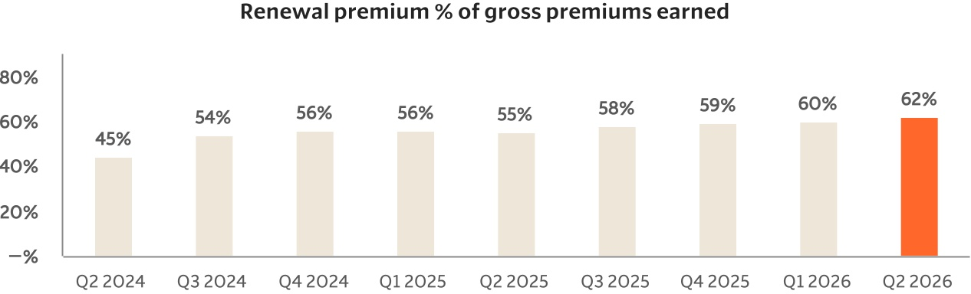
25

