UNITED STATES

SECURITIES AND EXCHANGE COMMISSION

WASHINGTON, D.C. 20549

__________

FORM 8-K

__________

CURRENT REPORT

Pursuant to Section 13 or 15(d) of the Securities Exchange Act of 1934

Date of Report (Date of earliest event reported): February 23, 2022

__________

ROOT, INC.

(Exact name of Registrant as Specified in Its Charter)

__________

Delaware | 001-39658 | 84-2717903
(State or Other Jurisdiction |  | (IRS Employer
of Incorporation) | (Commission File Number) | Identification No.)
80 E. Rich Street, Suite 500
Columbus, Ohio |  | 43215
(Address of Principal Executive Offices) |  | (Zip Code)
 | (866) 980-9431
 | (Registrant’s Telephone Number, Including Area Code)
 | Not Applicable
 | (Former Name or Former Address, if Changed Since Last Report)

__________

Check the appropriate box below if the Form 8-K filing is intended to simultaneously satisfy the filing obligation of the registrant under any of the following provisions (see General Instructions A.2. below):

- Written communications pursuant to Rule 425 under the Securities Act (17 CFR 230.425)

- Soliciting material pursuant to Rule 14a-12 under the Exchange Act (17 CFR 240.14a-12)

- Pre-commencement communications pursuant to Rule 14d-2(b) under the Exchange Act (17 CFR 240.14d-2(b))

- Pre-commencement communications pursuant to Rule 13e-4(c) under the Exchange Act (17 CFR 240.13e-4(c)) Securities registered pursuant to Section 12(b) of the Act:

 |  |  |  | Name of each exchange on
Title of each class |  | Trading Symbol(s) |  | which registered
Class A Common Stock, $0.0001 par value |  | ROOT |  | The Nasdaq Stock Market LLC

Indicate by check mark whether the registrant is an emerging growth company as defined in Rule 405 of the Securities Act of 1933 (§230.405 of this chapter) or Rule 12b-2 of the Securities Exchange Act of 1934 (§240.12b-2 of this chapter).

Emerging growth company ☐

If an emerging growth company, indicate by check mark if the registrant has elected not to use the extended transition period for complying with any new or revised financial accounting standards provided pursuant to Section 13(a) of the Exchange Act. ☐

Item 2.02 Results of Operations and Financial Condition.

On February 23, 2022, Root, Inc. (the "Company") announced its financial results for the fourth quarter and the full fiscal year ended December 31, 2021, by issuing a Letter to Shareholders (the "Letter"). In the Letter the Company also announced that it would be holding a conference call on February 24, 2022, at 8:00 a.m. Eastern Time to discuss its financial results for the fourth quarter and full fiscal year ended December 31, 2021. A copy of the Letter is furnished as Exhibit 99.1 to this Current Report and incorporated by reference herein.

The information contained in Item 2.02 of this Form 8-K (including Exhibit 99.1 attached hereto) shall not be deemed "filed" for purposes of Section 18 of the Securities Exchange Act of 1934, as amended (the "Exchange Act"), or otherwise subject to the liabilities of that section, nor shall it be deemed incorporated by reference in any filing under the Securities Act of 1933, as amended (the "Securities Act"), or the Exchange Act, except as expressly provided by specific reference in such a filing.

Item 7.01 Regulation FD Disclosure.

Hemal Shah, Chief Product Officer, has notified the Company of his intention to resign from the Company, effective March 18, 2022.

Matt Bonakdarpour was appointed Chief Technology Officer of the Company, effective February 23, 2022, and will oversee the Company’s Engineering and Data Science and Analytics organizations.

The information contained in Item 7.01 of this Form 8-K shall not be deemed "filed" for purposes of Section 18 of the Exchange Act, or otherwise subject to the liabilities of that section, nor shall it be deemed incorporated by reference in any filing under the Securities Act or the Exchange Act, except as expressly provided by specific reference in such a filing.

Item 9.01 Financial Statements and Exhibits.

(d) Exhibits

The following exhibit relating to Item 2.02 shall be deemed to be furnished:

Exhibit No. |  |  | Description
99.1 |  |  | Letter to Shareholders, dated February 23, 2022
104 |  |  | The cover page from this Current Report on Form 8-K, formatted in Inline XBRL.

SIGNATURES

Pursuant to the requirements of the Securities Exchange Act of 1934, as amended, the Registrant has duly caused this report to be signed on its behalf by the undersigned hereunto duly authorized.

ROOT, INC.

Dated: February 23, 2022

By: /s/ Alexander Timm

Alexander Timm

Chief Executive Officer and Director

Q4 2021

Shareholder Letter



Letter to Shareholders: FY 2021

____________________________________________________________________________________________________________

Key annual metrics:
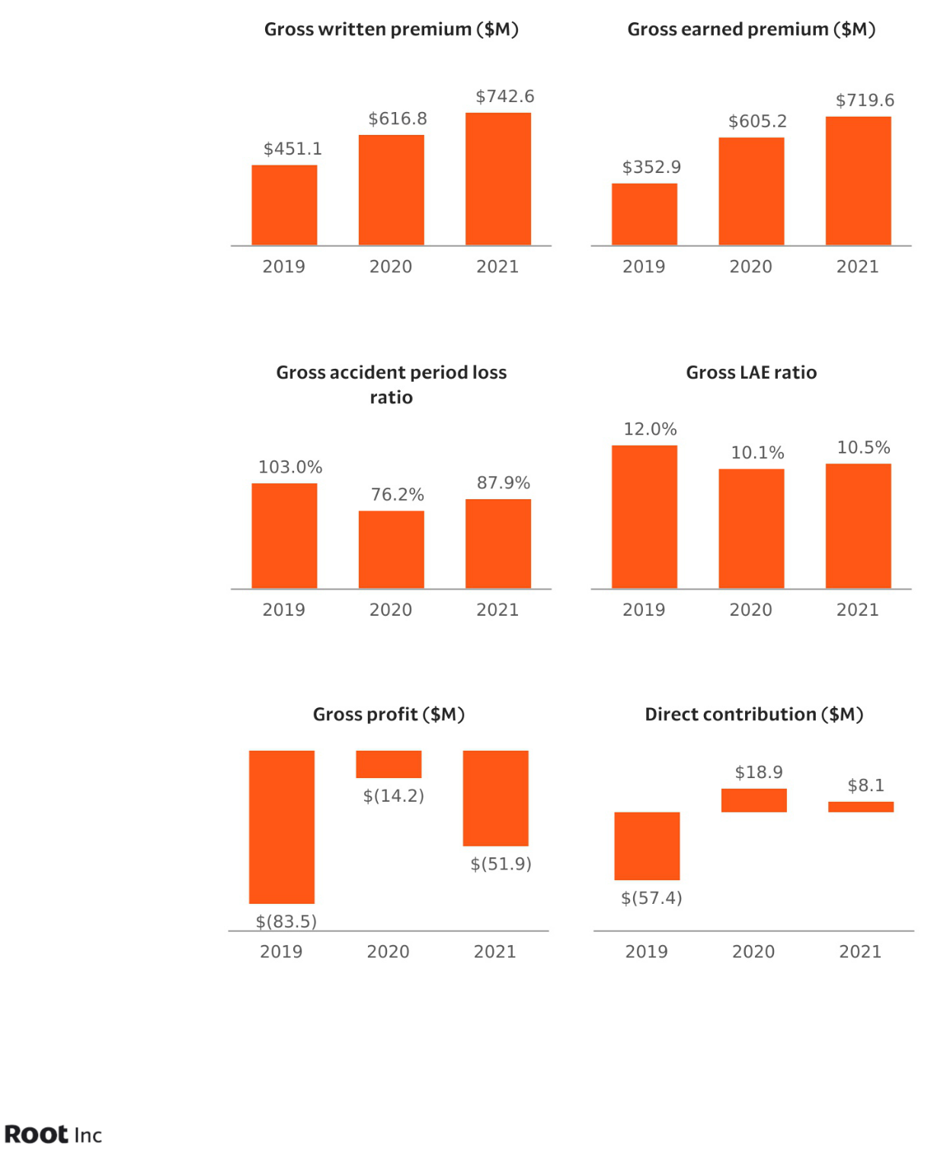

2

Letter to Shareholders: FY 2021

____________________________________________________________________________________________________________

Dear Shareholders:

2021 was a challenging year for insurtechs and auto insurer capital market investors as inflationary pressures led to rapidly accelerating loss trends. Despite the challenges of our new environment, Root’s technology has enabled us to not only recognize the trends early, but take swift action to proactively address these environmental pressures.

While we’ve learned from and adjusted to these challenges, our underlying belief in our business has not changed. By focusing on data science and technology, we continue to drive increased efficiencies and segmentation. With our transformational Carvana partnership, we are reinventing how and when insurance products are purchased. We believe these investments will meaningfully build better customer experiences and a path to profit.

Furthermore, we’re excited to say that our beliefs are backed by our data, as seen in our results:

- Stabilized loss ratios versus Q3 despite auto insurance peers continuing to report sequential increases in Q4. This was a result of improved underwriting, segmentation, and state management efforts. The speed at which we responded to trend was only possible because our data science and technology allowed us to spot the trend early and act quickly. To do this while also shipping the next generation of our segmentation models is our strategy in action.

- Shipped and iterated on the Carvana embedded product, increasing weekly new writings from our platform by 3.5x and setting the groundwork for further expansion.
- Reduced direct operating loss from $172 million in Q2 to $92 million in Q4.

- Materially reduced our cash burn in response to the loss environment by cutting marketing spend by 62% in Q4 and run-rate fixed expenses by roughly $48 million annually from peak 2021 levels. This material, decisive action shows our agility and ability to optimize for profit when the environment calls for it.
- Closed our BlackRock term loan facility of $300 million with a 5-year duration in Q1’22. This is both longer duration and larger than any facility we have secured to date, providing new capital for us to focus on our long-term path to profit.

When scaling an insurance company, there are high fixed costs upfront—product development, acquisition costs, and the cost to acquire data to train our algorithms. Over the last six years, we have borne many of these costs as we strengthen the competitive advantage that comes from our data science and technology. As we mature and our environment has shifted, the focus on the profitability of the business we’re writing has improved significantly over the last few quarters. We believe we have line of sight to profitable unit economics and capital to execute on the strategic priorities to get us there.

3

Letter to Shareholders: FY 2021

____________________________________________________________________________________________________________

Q4 2021 highlights:

All figures are compared to Q4 2020 unless otherwise stated.

- Gross written premium increased 9% to $158 million

- Gross earned premium increased 22% to $189 million; Gross earned premium from seasoned states was 77%
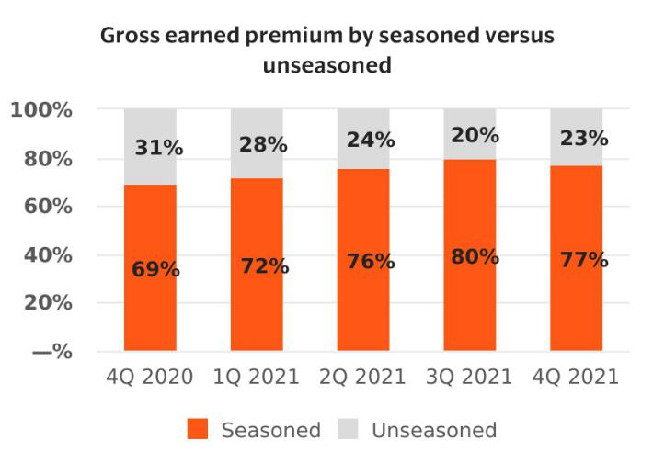

- Renewal premium % of gross earned premiums remained roughly steady over Q4 2020 at 63%.
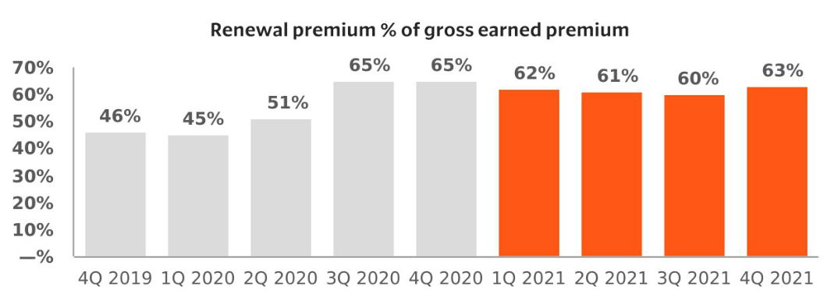

- Gross profit decreased by $17 million to $(23) million as our results remain pressured by the current loss cost environment

4

Letter to Shareholders: FY 2021

____________________________________________________________________________________________________________

Customer Experience

We fight every day to meet a customer’s evolving needs by leveraging our technology to dramatically improve the customer experience. Our unique ability to meet consumers where they are with embedded products enables us to cost-efficiently address a pressing auto insurance need at the point it arises. The combination of convenience, fair pricing, and unparalleled customer service from binding through claims are the building blocks of long-term customer loyalty.

Carvana update

Our exclusive partnership with Carvana is the first step to building an industry-leading embedded experience with the ideal partner that is the fastest-growing auto seller in the United States and shares our passion for the customer experience. This product provides attractive customer acquisition costs to high-retaining customers. We announced the partnership in August and got to work with our Carvana counterparts immediately. Through our shared commitment to build the very best technology, the quality and effectiveness of what we’ve been able to develop in less than six months has surpassed expectations on both sides. We are openly collaborating so we can rapidly iterate on the product.

Fast-follow improvements in the first version of the embedded product include a quote presented as part of the Carvana workflow, automated proof of insurance, pre-filled bind flow, and less than our average 47 seconds needed for the customer to obtain a “Carvana Insurance, Built with Root” policy. Additionally, Carvana’s reconditioning centers allow for full knowledge of the condition of the car before a quote is presented to a customer, driving more accuracy for us and less disruption to the customer. While it’s early, and we’re adding new states to the embedded footprint each week, the metrics around attach rate, loss ratio, and retention look extremely positive. We expect that Carvana customers will represent a material percentage of our new writings in Q1 and continue to build throughout the year.

As we have driven product market fit, Carvana decided to increase our share of traffic. This shift took place months ahead of what was committed to in our initial agreement, reflecting both the success of the partnership and Carvana’s enthusiasm over the level of interest their customers have shown in our embedded offering. We expect to continue to improve customer adoption as we dramatically improve customer experience, learn more around what drives bind rates, and continue testing.

5

Letter to Shareholders: FY 2021

____________________________________________________________________________________________________________



Our next step is focused on building V2 of our embedded product with Carvana. This includes exploring how we could use telematics information in pricing, underwriting, and customer experience. We also are building a brokerage offering to serve customers in states where Root doesn’t currently write business.

Distribution / Expansion

We continue to leverage our technology platform to diversify our distribution channels. We’ve decided to further focus on our fully embedded products, given the level of customer adoption we are seeing in the early days.
We have also received tremendous interest in our embedded insurance offering from other prospective partners, though our focus remains on our exclusive Carvana partnership. We continue to test diverse methods of distribution on a smaller scale. As we drive toward underwriting profitability, our appetite for scaling these investments will grow.

Underwriting

Our data science and technology advantage has created what we believe to be some of most powerful models in the industry. For these models to shine, we need to drive improvement in our traditional underwriting abilities and state management. This will accelerate our path to profit. Our results in Q4 demonstrate how Root leverages its data to gain insight into shifting trends and technology to implement change quickly. While many in the industry

6

Letter to Shareholders: FY 2021

____________________________________________________________________________________________________________

have experienced an escalating impact of loss cost trends impacting quarterly results, we have maintained a relatively steady accident period loss ratio the past three quarters. We also noted a decrease in miles driven towards the end of Q4, benefiting the frequency we experienced in our book. While the loss ratio remaining flat is a positive data point in this environment, a 90% loss ratio is well above our stated goal of 65%.
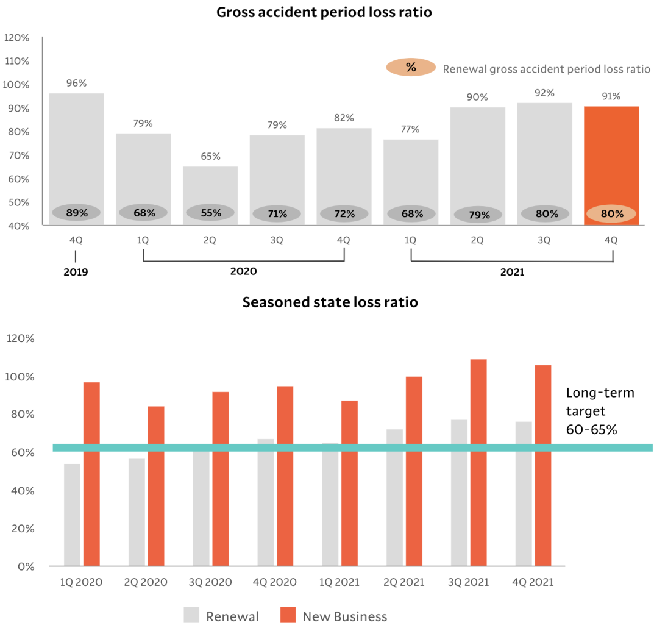

We continue to advance our machine learning loss models, allowing Root to respond more quickly to changes

in the market, improve pricing segmentation through enhancements to McModel, our countrywide pricing model, as well as take rate increases in response to inflation. In the fourth quarter, eight rate increases were implemented with an additional five implemented quarter-to-date. Cumulatively since the beginning of 2021, we have

7

Letter to Shareholders: FY 2021

____________________________________________________________________________________________________________

implemented 42 rate increases with a weighted average rate of roughly 14%, impacting the vast majority of our premium. We are also seeing a marked improvement in frequency from UBI 4.0, further demonstrating how the predictive power of our technology translates into measurable results.
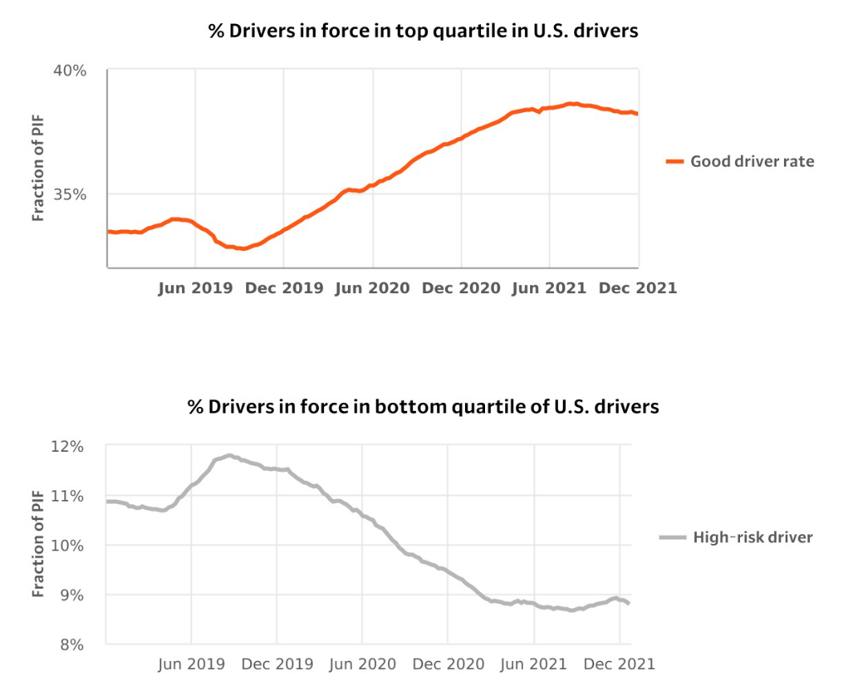

In addition to positioning ourselves to address the immediate need of appropriately reflecting cost in our pricing, we are committed to strengthening our underwriting foundation. We are tightening our underwriting standards and rolling out improved policy forms to manage loss leakage. We are leaning on our state level management to better work within each individual jurisdiction and take a more surgical approach in responding to the current loss environment.

Taken together, we expect these actions to drive improvement in our loss ratio throughout the year and bring our performance closer to our stated goal of 65%.

8

Letter to Shareholders: FY 2021

____________________________________________________________________________________________________________

Path to profit

Root is committed to building an enduring business for the long term. To achieve this, we have solidly prioritized our capital investments. We began implementing operating changes across the business early in Q3. We substantially reduced direct marketing spend in response to the elevated macro loss environment and customer acquisition cost in digital channels. During the Q4, we reduced our sales and marketing spend by 62% sequentially, in addition to the 40% sequential drop we experienced in the Q3.

Our commitment to our path to profit did not stop at marketing spend. This work underpinned the difficult decision we took in January to reduce our workforce by approximately 20%, resulting in run-rate expense savings of approximately $30 million annually. We expect to incur approximately $7 million in severance, benefits, and related costs related to the workforce reduction as well as approximately $2 million in real estate exit costs in Q1’22. This was another prudent move for our business, given the deep focus on key strategic priorities. We will continue to take action to manage our capital consumption while investing in the areas of the business where we see the greatest potential: further developing our embedded product with Carvana, developing additional embedded product partnerships, strengthening our underwriting foundation, and continuing to utilize our technology to address long-standing inefficiency in the auto insurance industry.

We are confident that the changes made and underway, combined with our unique ability to respond quickly to today’s insurance environment, will establish a solid path to profitability and secure our future success.

Looking ahead

We continue to execute on the goals we set out during Q2’21. We are using our technology and customer knowledge to gain differentiated access to customers to acquire profitable business. We are improving our insurance operations, making extraordinary leaps forward in our partnership with Carvana, and prudently managing capital. In the face of an uncertain auto environment, we continue to expect gross written premium to reflect significant year-over-year declines in the first half of 2022 as we take active steps to take underwriting/pricing actions to react to the loss cost environment, prepare to ramp up our Carvana partnership in the back half of the year, and materially reduce our operating loss. We also continue to expect a meaningful improvement in full-year operating losses in 2022 as we prioritize expense management and reduce capital consumption. With further reduction in marketing costs and fixed expenses on a year-over-year basis, we expect approximately 25% operating loss improvement in the first half of 2022¹. We are planning to host an investor day in September in New York, NY. This platform will give Root the opportunity to give a greater level of detail on future expectations for the business, including operating performance for the back half of the year.

- Before restructuring charge of $9-12 million

9

Letter to Shareholders: FY 2021

____________________________________________________________________________________________________________

We sit in a stronger position than we have at any other time in Root’s history. Our ability to quickly iterate and implement changes not only makes us stronger in the volatile environment we face today but is a core part of the infrastructure that makes Root built to last. Our near-term goals are clear: continuing to capitalize on our technology advantage, strengthen our underwriting foundation, and building out our embedded product through our partnership with Carvana. The success of this focus can be measured in our top and bottom-line results in coming quarters and years ahead.

We appreciate your continued support and look forward to what’s ahead for Root.


Alex Timm

Daniel Rosenthal

Co-Founder & CEO

CROO & CFO

10

Letter to Shareholders: FY 2021

____________________________________________________________________________________________________________

Non-GAAP financial measures

This letter and statements made during the above referenced webcast may include information relating to Adjusted Gross Profit (Loss) and Direct Contribution, which are "non-GAAP financial measures." These non-GAAP financial measures have not been calculated in accordance with generally accepted accounting principles in the United States, or GAAP, and should be considered in addition to results prepared in accordance with GAAP,

GAAP Gross Profit (Loss), and should not be considered as a substitute for, or superior to, GAAP results.

In addition, Adjusted Gross Profit (Loss) and Direct Contribution should not be construed as indicators of our operating performance, liquidity, or cash flows generated by operating, investing and financing activities,
as there may be significant factors or trends that they fail to address. We caution investors that non-GAAP financial information, by its nature, departs from traditional accounting conventions. Therefore, its use can make it difficult to compare our current results with our results from other reporting periods and with the results of other companies.

Our management uses these non-GAAP financial measures, in conjunction with GAAP financial measures, as an integral part of managing our business and to, among other things: (1) monitor and evaluate the performance of our business operations and financial performance, (2) facilitate internal comparisons of the historical operating performance of our business operations, (3) facilitate external comparisons of the results of our overall business to the historical operating performance of other companies that may have different capital structures and debt level, (4) review and assess the operating performance of our management team, (5) analyze and evaluate financial and strategic planning decisions regarding future operating investments, and (6) plan for and prepare future annual operating budgets and determine appropriate levels of operating investments.

We have not reconciled Adjusted Gross Profit (Loss) and Direct Contribution outlook to GAAP Gross Profit (Loss) because we do not provide an outlook for GAAP Gross Profit (Loss) due to the uncertainty and potential variability of factors used to calculate GAAP Gross Profit (Loss). Because we cannot reasonably predict such items,
a reconciliation of the non-GAAP financial measure outlook to the corresponding GAAP measure is not available without unreasonable effort. We caution, however, that such items could have a significant impact on the calculation of GAAP Gross Profit (Loss).

For more information regarding the non-GAAP financial measures discussed in this release, please see “Non-GAAP financial measures” and “Reconciliation of GAAP to non-GAAP financial measures” below.

11

Letter to Shareholders: FY 2021

____________________________________________________________________________________________________________

Forward-looking statements

This letter contains—and statements made during the above-referenced webcast will contain— forward-looking statements relating to, among other things, the future performance of Root and its consolidated subsidiaries that are based on Root’s current expectations, forecasts, and assumptions, and involve risks and uncertainties.
These include, but are not limited to, statements regarding:

- Our expected financial results for 2022

- Our ability to build new versions of our embedded insurance offering

- Our ability to reduce customer acquisition costs, realize other expected benefits and drive a significant long-term competitive advantage through our partnership with Carvana and with our embedded insurance offering
- Our ability to retain existing customers, acquire new customers, and expand our customer reach, and expand our distribution channels through additional partnership relationships, digital media and referrals
- Our ability to remove the use of credit score from our rating variables no later than 2025

- Our expectations regarding our future financial performance, including total revenue, gross profit, adjusted gross profit, direct contribution, gross loss ratio, marketing costs and costs of customer acquisition, gross LAE ratio, quota share levels, and expansion of our renewal premium base
- The impact of the COVID-19 pandemic on our business and financial performance

- Our goal to be licensed in all states in the United States and the timing of obtaining additional licenses and launching in new states
- The accuracy and efficiency of our telematics and behavioral data, and our ability to gather and leverage additional data

- Our ability to materially improve retention rates and our ability to realize benefits from retaining customers

- Our ability to release new products and features and the timing and effectiveness of those releases, including our new Algorithm Version 4.0, McModel 4.1, and Carvana V2
- Our ability to underwrite risks accurately and charge profitable rates

- Our ability to drive improved conversion and decrease the costs of customer acquisition with improved customer characteristics

- Our ability to realize the benefits anticipated from our Texas county mutual fronting arrangement

- Our ability maintain and enhance our brand and reputation

- Our ability to compete effectively with existing competitors and new market entrants in our industry

- Our ability to operate a “capital-light” business and obtain and maintain reinsurance contracts

- Our ability to realize economies of scale and grow margins

- Our ability to expand our distribution channels through additional partnership relationships, independent agencies, digital media, and referrals

12

Letter to Shareholders: FY 2021

____________________________________________________________________________________________________________

- Our ability to protect our intellectual property and any costs associated therewith

- Our ability to expand domestically and internationally

- Our ability to deliver a vertically integrated customer experience

- Our ability to develop products that utilize our telematics to drive better customer satisfaction and retention
- Our ability to develop an autonomous claims experience

- Our ability to take rate action early and react to changing environments

- Our ability to attract, motivate and retain key personnel, or hire personnel, in a competitive labor market and to offer competitive compensation and benefits
- Our ability to raise additional capital as needed, maintain compliance with our term loan agreement, meet risk-based capital requirements, stay in compliance with laws and regulation that currently apply or become applicable to our business

Root’s actual results could differ materially from those predicted or implied by such forward-looking statements, and reported results should not be considered as an indication of future performance.

Factors that could cause or contribute to such differences also include, but are not limited to, those factors that could affect Root’s business, operating results, and stock price included under the captions “Risk Factors” and “Management’s Discussion and Analysis of Financial Condition and Results of Operations” in Root’s 2021 Annual Report on Form 10-K at http://ir.joinroot.com or the SEC’s website at www.sec.gov.

Undue reliance should not be placed on the forward-looking statements in this letter or the above-referenced webcast, which are based on information available to Root on the date hereof. Such forward-looking statements do not include the potential impact of any acquisitions or divestitures that may be announced and/or completed after the date hereof. We assume no obligation to update such statements.

13

Letter to Shareholders: FY 2021

____________________________________________________________________________________________________________

Financial statements

ROOT, INC. AND SUBSIDIARIES

CONDENSED CONSOLIDATED BALANCE SHEETS - UNAUDITED

 |  | As of
 |  | 2021 |  |  | 2020
 |  | (in millions, except par value )
Assets
Investments:
Fixed maturities available-for-sale, at fair value (amortized cost: $129.5 and $215.4 at December 31, 2021 and | $ | 129.9 |  | $ | 221.0
December 31, 2020, respectively) | $ | 129.9 |  | $ | 221.0
Short-term investments (amortized cost: zero and $3.0 at December 31, 2021 and December 31, 2020, respectively) |  | — |  |  | 3.0
Other investments |  | 4.7 |  |  | 0.5
Total investments |  | 134.6 |  |  | 224.5
Cash and cash equivalents |  | 706.0 |  |  | 1,112.8
Restricted cash |  | 1.0 |  |  | 1.0
Premiums receivable, net of allowance of $5.4 and $3.5 at December 31, 2021 and December 31, 2020, respectively |  | 148.1 |  |  | 130.1
Reinsurance recoverable, net of allowance of $0.2 and zero at December 31, 2021 and December 31, 2020, respectively |  | 155.0 |  |  | 124.8
Prepaid reinsurance premiums |  | 100.8 |  |  | 112.8
Other assets |  | 73.8 |  |  | 56.3
Total assets | $ | 1,319.3 |  | $ | 1,762.3
Liabilities, Redeemable Convertible Preferred Stock and Stockholders’ Equity
Liabilities:
Loss and loss adjustment expense reserves | $ | 320.2 |  | $ | 237.2
Unearned premiums |  | 180.1 |  |  | 157.1
Long-term debt and warrants |  | — |  |  | 188.2
Reinsurance premiums payable |  | 101.6 |  |  | 89.1
Accounts payable and accrued expenses |  | 29.1 |  |  | 48.0
Other liabilities |  | 39.9 |  |  | 10.3
Total liabilities |  | 670.9 |  |  | 729.9
Commitments and Contingencies
Redeemable convertible preferred stock, $0.0001 par value, 14.1 and zero shares issued and outstanding at
December 31, 2021 and December 31, 2020, respectively (liquidation preference of $126.5 and zero, |  | 112.0 |  |  | —
respectively) |  | 112.0 |  |  | —
Stockholders’ equity:
Class A common stock, $0.0001 par value, 142.9 and 59.4 shares issued and outstanding at December 31, 2021 and |  | — |  |  | —
December 31, 2020, respectively |  |  |  |  | —
Class B common stock, $0.0001 par value, 109.9 and 192.2 shares issued and outstanding at December 31, 2021 and |  | — |  |  | —
December 31, 2020, respectively |  |  |  |  | —
Treasury stock, at cost |  | — |  |  | (0.8)
Additional paid-in capital |  | 1,806.1 |  |  | 1,775.6
Accumulated other comprehensive income |  | 0.4 |  |  | 5.6
Accumulated loss |  | (1,270.1) |  |  | (748.0)
Total stockholders’ equity |  | 536.4 |  |  | 1,032.4
Total liabilities, redeemable convertible preferred stock and stockholders’ equity | $ | 1,319.3 |  | $ | 1,762.3

14

Letter to Shareholders: FY 2021

____________________________________________________________________________________________________________

ROOT, INC. AND SUBSIDIARIES

CONDENSED CONSOLIDATED STATEMENTS OF OPERATIONS AND COMPREHENSIVE LOSS - UNAUDITED

 | Three Months Ended December 31, |  |  |  |  |  |  | Years Ended December 31,
 | 2021 |  |  |  | 2020 |  |  | 2021 |  |  | 2020
 |  |  |  |  | (in millions, except per share data)
Revenues:
Net premiums earned | $ | 84.9 |  | $ | 44.1 |  | $ | 310.3 |  | $ | 322.5
Net investment income |  | 2.4 |  |  | 1.1 |  |  | 5.0 |  |  | 5.4
Net realized gains on investments |  | — |  |  | 0.1 |  |  | 2.4 |  |  | 0.3
Fee income |  | 5.2 |  |  | 4.4 |  |  | 20.9 |  |  | 17.4
Other income |  | 0.7 |  |  | 1.2 |  |  | 6.8 |  |  | 1.2
Total revenues |  | 93.2 |  |  | 50.9 |  |  | 345.4 |  |  | 346.8
Operating expenses:
Loss and loss adjustment expenses |  | 107.8 |  |  | 59.5 |  |  | 392.3 |  |  | 362.8
Sales and marketing |  | 24.7 |  |  | 49.6 |  |  | 270.2 |  |  | 139.7
Other insurance expense (benefit) |  | 8.6 |  |  | (2.1) |  |  | 5.0 |  |  | (1.8)
Technology and development |  | 16.2 |  |  | 12.7 |  |  | 65.5 |  |  | 52.9
General and administrative |  | 27.8 |  |  | 19.7 |  |  | 97.6 |  |  | 78.5
Total operating expenses |  | 185.1 |  |  | 139.4 |  |  | 830.6 |  |  | 632.1
Operating loss |  | (91.9) |  |  | (88.5) |  |  | (485.2) |  |  | (285.3)
Interest expense |  | (2.1) |  |  | (44.8) |  |  | (20.0) |  |  | (77.7)
Loss on early extinguishment of debt |  | (15.9) |  |  | — |  |  | (15.9) |  |  | —
Loss before income tax expense |  | (109.9) |  |  | (133.3) |  |  | (521.1) |  |  | (363.0)
Income tax expense |  | — |  |  | — |  |  | — |  |  | —
Net loss |  | (109.9) |  |  | (133.3) |  |  | (521.1) |  |  | (363.0)
Other comprehensive (loss) income:
Changes in net unrealized (losses) gains on investments |  | (1.2) |  |  | — |  |  | (5.2) |  |  | 5.0
Comprehensive loss | $ | (111.1) |  | $ | (133.3) |  | $ | (526.3) |  | $ | (358.0)
Loss per common share: basic and diluted (both Class A and B)
 | $ | (0.44) |  | $ | (0.72) |  | $ | (2.09) |  | $ | (4.81)
Weighted-average common shares outstanding: basic and diluted |  | 250.3 |  |  | 185.4 |  |  | 249.2 |  |  | 75.5
(both Class A and B) |  | 250.3 |  |  | 185.4 |  |  | 249.2 |  |  | 75.5

15

Letter to Shareholders: FY 2021

____________________________________________________________________________________________________________

ROOT, INC. AND SUBSIDIARIES

CONDENSED CONSOLIDATED STATEMENTS OF CASH FLOWS - UNAUDITED

 | 2021 |  |  |  | 2020
 |  | (in millions)
Cash flows from operating activities:
Net loss | $ | (521.1) |  | $ | (363.0)
Adjustments to reconcile net loss to net cash used in operating activities:
Share-based compensation |  | 19.3 |  |  | 3.7
Warrant compensation expense |  | 8.8 |  |  | —
Tender offer |  | — |  |  | 25.1
Depreciation and amortization |  | 16.6 |  |  | 15.6
Bad debt expense |  | 20.9 |  |  | 23.6
Loss on early extinguishment of debt |  | 15.9 |  |  | —
Warrants fair value adjustment |  | — |  |  | 54.7
Paid-in-kind interest expense |  | 10.6 |  |  | 9.1
Paid-in-kind interest paid |  | (20.5) |  |  | —
Net realized gains on investments |  | (2.4) |  |  | (0.3)
Change in fair value of equity securities |  | (3.8) |  |  | —
Changes in operating assets and liabilities:
Premiums receivable |  | (39.7) |  |  | (31.0)
Reinsurance recoverable |  | (30.4) |  |  | (99.5)
Prepaid reinsurance premiums |  | 12.0 |  |  | (95.4)
Other assets |  | 0.8 |  |  | (21.7)
Losses and loss adjustment expenses reserves |  | 83.0 |  |  | 96.5
Unearned premiums |  | 23.0 |  |  | 11.7
Reinsurance premiums payable |  | 12.5 |  |  | 63.4
Accounts payable and accrued expenses |  | (19.2) |  |  | 18.2
Other liabilities |  | 10.3 |  |  | 2.1
Net cash used in operating activities |  | (403.4) |  |  | (287.2)
Cash flows from investing activities:
Purchases of investments |  | (17.0) |  |  | (158.4)
Proceeds from maturities, call and pay downs of investments |  | 34.7 |  |  | 42.5
Sales of investments |  | 70.4 |  |  | 17.9
Purchases of indefinite-lived intangible assets and transaction costs |  | — |  |  | (8.9)
Capitalization of internally developed software |  | (6.6) |  |  | (5.4)
Purchases of fixed assets |  | (4.6) |  |  | (1.8)
Net cash provided by (used in) investing activities |  | 76.9 |  |  | (114.1)
Cash flows from financing activities:
Proceeds from issuance of common stock from IPO and concurrent private placements, net of issuance costs |  | — |  |  | 1,098.1
Proceeds from exercise of stock options and restricted stock units, net of tax proceeds/(withholding) |  | 3.2 |  |  | 2.1
Proceeds from issuance of preferred stock and related warrants |  | 126.5 |  |  | —
Payment of preferred stock and related warrants issuance costs |  | (10.5) |  |  | —
Proceeds from issuance of debt and related warrants, net of issuance costs |  | — |  |  | 12.0
Repayments of long-term debt |  | (199.5) |  |  | (13.5)
Purchases of treasury stock |  | — |  |  | (0.2)
Net cash (used in) provided by financing activities |  | (80.3) |  |  | 1,098.5
Net (decrease) increase in cash, cash equivalents and restricted cash |  | (406.8) |  |  | 697.2
Cash, cash equivalents and restricted cash at beginning of year |  | 1,113.8 |  |  | 416.6
Cash, cash equivalents and restricted cash at end of year | $ | 707.0 |  | $ | 1,113.8

16

Letter to Shareholders: FY 2021

____________________________________________________________________________________________________________

Supplemental financial information

ROOT, INC. AND SUBSIDIARIES

KEY PERFORMANCE INDICATORS - UNAUDITED

 |  | Three Months Ended December 31, |  |  |  | Years Ended December 31,
 |  | 2021 |  | 2020 |  | 2021 |  | 2020
 |  |  |  | (dollars in millions, except Premiums per Policy)
Policies in force
Auto |  | 354,371 |  | 322,759 |  | 354,371 |  | 322,759
Renters |  | 8,802 |  | 7,739 |  | 8,802 |  | 7,739
Premiums per policy
Auto | $ | 1,006 | $ | 939 | $ | 1,006 | $ | 939
Renters | $ | 140 | $ | 140 | $ | 140 | $ | 140
Premiums in force
Auto | $ | 713.0 | $ | 606.1 | $ | 713.0 | $ | 606.1
Renters | $ | 1.2 | $ | 1.1 | $ | 1.2 | $ | 1.1
Gross written premium⁽¹⁾ | $ | 158.4 | $ | 145.7 | $ | 742.6 | $ | 616.8
Gross earned premium⁽¹⁾ | $ | 189.3 | $ | 155.0 | $ | 719.6 | $ | 605.2
Gross profit/(loss) | $ | (23.2) | $ | (6.5) | $ | (51.9) | $ | (14.2)
Gross margin |  | (24.9)% |  | (12.8)% |  | (15.0)% |  | (4.1)%
Adjusted gross profit/(loss) | $ | (13.8) | $ | 3.9 | $ | (3.3) | $ | 21.0
Direct contribution | $ | (4.2) | $ | 13.5 | $ | 8.1 | $ | 18.9
Ratio of adjusted gross profit/(loss) to total revenue |  | (14.8)% |  | 7.7 % |  | (1.0)% |  | 6.1 %
Ratio of adjusted gross profit/(loss) to gross earned premium |  | (7.3)% |  | 2.5 % |  | (0.5)% |  | 3.5 %
Ratio of direct contribution to total revenue |  | (4.5)% |  | 26.5 % |  | 2.3 % |  | 5.4 %
Ratio of direct contribution to gross earned premium |  | (2.2)% |  | 8.7 % |  | 1.1 % |  | 3.1 %
Gross loss ratio |  | 88.5 % |  | 75.8 % |  | 86.0 % |  | 82.0 %
Gross LAE ratio |  | 11.0 % |  | 11.1 % |  | 10.5 % |  | 10.1 %
Gross accident period loss ratio |  | 90.7 % |  | 81.5 % |  | 87.9 % |  | 76.2 %

_____________

- Includes premiums assumed from the fronting carrier that commenced in August 2021. Assumed written premiums and assumed earned premium for the three months ended December 31, 2021 were $9.1 million and $6.3 million, respectively. Assumed written premium and assumed earned premium for the year ended December 31, 2021 were $16.7 million and $7.3 million, respectively. Prior to the fronting carrier commencement, we did not assume any premiums.

17

Letter to Shareholders: FY 2021

____________________________________________________________________________________________________________

ROOT, INC. AND SUBSIDIARIES

RECONCILIATION OF TOTAL REVENUE TO GROSS PROFIT/(LOSS), ADJUSTED GROSS PROFIT/(LOSS) AND DIRECT CONTRIBUTION -
UNAUDITED

 |  | Three Months Ended December 31,
 | 2021 |  |  |  | 2020 |  |  | 2019
 |  |  |  |  | (dollars in millions)
Total revenue | $ | 93.2 |  | $ | 50.9 |  | $ | 106.5
Loss and loss adjustment expenses |  | (107.8) |  |  | (59.5) |  |  | (110.9)
Other insurance (expense) benefit |  | (8.6) |  |  | 2.1 |  |  | (18.2)
Gross profit/(loss) | $ | (23.2) |  | $ | (6.5) |  | $ | (22.6)
Gross margin |  | (24.9)% |  |  | (12.8)% |  |  | (21.2)%
Less:
Net investment income | $ | (2.4) |  | $ | (1.1) |  | $ | (2.4)
Net realized gains on investments |  | — |  |  | (0.1) |  |  | —
Adjustments from other insurance (expense) benefit⁽¹⁾ |  | 11.8 |  |  | 11.6 |  |  | 10.8
Adjusted gross profit/(loss) |  | (13.8) |  |  | 3.9 |  |  | (14.2)
Ceded earned premium |  | 104.4 |  |  | 110.9 |  |  | 18.7
Ceded loss and loss adjustment expenses |  | (80.5) |  |  | (75.2) |  |  | (15.8)
Net ceding commission and other⁽²⁾ |  | (14.3) |  |  | (26.1) |  |  | (1.5)
Direct contribution |  | (4.2) |  |  | 13.5 |  |  | (12.8)
Gross earned premium | $ | 189.3 |  | $ | 155.0 |  | $ | 119.6
Ratio of adjusted gross profit/(loss) to total revenue |  | (14.8)% |  |  | 7.7 % |  |  | (13.3)%
Ratio of adjusted gross profit/(loss) to gross earned premium |  | (7.3)% |  |  | 2.5 % |  |  | (11.9)%
Ratio of direct contribution to total revenue |  | (4.5)% |  |  | 26.5 % |  |  | (12.0)%
Ratio of direct contribution to gross earned premium |  | (2.2)% |  |  | 8.7 % |  |  | (10.7)%

______________

- Adjustments from other insurance expense includes report costs, personnel costs, allocated overhead, licenses, professional fees and other.

- Net ceding commission and other is comprised of ceding commissions received in connection with reinsurance ceded, partially offset by sliding scale commission adjustments and amortization of excess ceding commission, and other impacts of reinsurance.

18

Letter to Shareholders: FY 2021

____________________________________________________________________________________________________________

ROOT, INC. AND SUBSIDIARIES

RECONCILIATION OF TOTAL REVENUE TO GROSS PROFIT/(LOSS), ADJUSTED GROSS PROFIT/(LOSS) AND DIRECT CONTRIBUTION -
UNAUDITED

 |  |  |  | Years Ended December 31,
 | 2021 |  |  |  | 2020 |  |  | 2019
Total revenue | $ | 345.4 |  | $ | 346.8 |  | $ | 290.2
Loss and loss adjustment expenses |  | (392.3) |  |  | (362.8) |  |  | (321.4)
Other insurance (expense) benefit |  | (5.0) |  |  | 1.8 |  |  | (52.3)
Gross profit/(loss) | $ | (51.9) |  | $ | (14.2) |  | $ | (83.5)
Gross margin |  | (15.0)% |  |  | (4.1)% |  |  | (28.8)%
Less:
Net investment income | $ | (5.0) |  | $ | (5.4) |  | $ | (5.2)
Net realized gains on investments |  | (2.4) |  |  | (0.3) |  |  | —
Adjustments from other insurance (expense) benefit⁽¹⁾ |  | 56.0 |  |  | 40.9 |  |  | 34.5
Adjusted gross profit/(loss) |  | (3.3) |  |  | 21.0 |  |  | (54.2)
Ceded earned premium |  | 409.3 |  |  | 282.7 |  |  | 77.6
Ceded loss and loss adjustment expenses |  | (302.5) |  |  | (194.8) |  |  | (73.6)
Net ceding commission and other⁽²⁾ |  | (95.4) |  |  | (90.0) |  |  | (7.2)
Direct contribution |  | 8.1 |  |  | 18.9 |  |  | (57.4)
Gross earned premium | $ | 719.6 |  | $ | 605.2 |  | $ | 352.9
Ratio of adjusted gross profit/(loss) to total revenue |  | (1.0)% |  |  | 6.1 % |  |  | (18.7)%
Ratio of adjusted gross profit/(loss) to gross earned premium |  | (0.5)% |  |  | 3.5 % |  |  | (15.4)%
Ratio of direct contribution to total revenue |  | 2.3 % |  |  | 5.4 % |  |  | (19.8)%
Ratio of direct contribution to gross earned premium |  | 1.1 % |  |  | 3.1 % |  |  | (16.3)%

______________

- Adjustments from other insurance expense includes report costs, personnel costs, allocated overhead, licenses, professional fees and other.

- Net ceding commission and other is comprised of ceding commissions received in connection with reinsurance ceded, partially offset by sliding scale commission adjustments and amortization of excess ceding commission, and other impacts of reinsurance.

19

Letter to Shareholders: FY 2021

____________________________________________________________________________________________________________

ROOT, INC. AND SUBSIDIARIES

WRITTEN AND EARNED PREMIUM - UNAUDITED

Gross written premium

Ceded written premium

Net written premium

Gross earned premium

Ceded earned premium

Net earned premium

 | Three Months Ended December 31, |  |  |  |  |  | Years Ended December 31,
 | 2021 |  |  | 2020 |  |  | 2021 |  |  | 2020
 |  |  |  | (dollars in millions)
$ | 158.4 |  | $ | 145.7 |  | $ | 742.6 |  | $ | 616.8
 | (90.5) |  |  | (103.3) |  |  | (397.3) |  |  | (378.0)
 | 67.9 |  |  | 42.4 |  |  | 345.3 |  |  | 238.8
 | 189.3 |  |  | 155.0 |  |  | 719.6 |  |  | 605.2
 | (104.4) |  |  | (110.9) |  |  | (409.3) |  |  | (282.7)
$ | 84.9 |  | $ | 44.1 |  | $ | 310.3 |  | $ | 322.5

20

